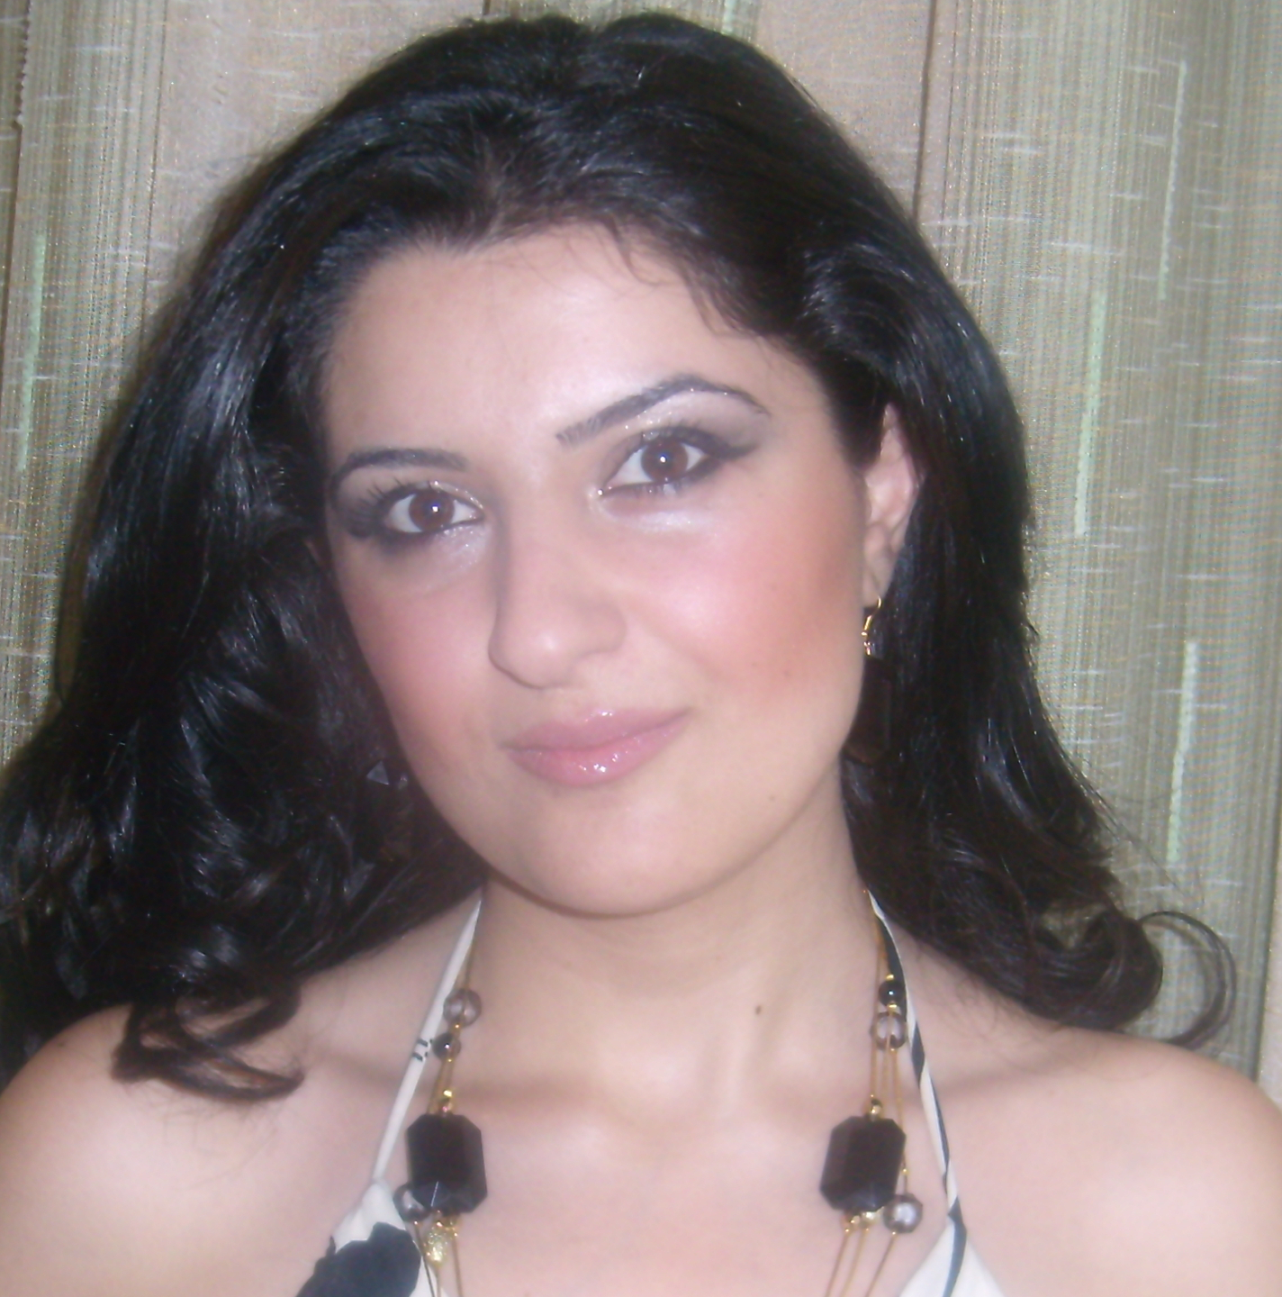
10 A. Khachatryan Str, apt.8, Yerevan,Armenia

Tel: (+374 10) 26.02.27, (+374 93) 755.766

e-mail: arpi@armenianow.com
arpi_harutyunyan@yahoo.com

ARPI HARUTYUNYAN

DATE OF BIRTH: 23.02.1984

EDUCATION:

2009 –to present Post graduate study , PHD on “Journalism and Ecology”
Department of Journalism, Yerevan State University

2006 Master Degree in Journalism
Department of Journalism, Yerevan State University

2000 -2004 Bachelor’s Degree in Journalism
Department of Journalism, Yerevan State University

  - “Quant” College, Yerevan

WORK EXPERIENCE:

2009-to present PR Administratior, “All Youth Fund”

2009-to present News coordinator, “Armenian Assembly of America”, “Armenianow”
on- line weekly

2008-to present Press officer, “Haypost” CJSC

2008 News coordinator, “National Idea” on-line agency

2008 Reporter, “Hraparak” daily

2008-to present Correspondent, “Transitions on-line” internet journal

2005-2007 PR Administrator, Armenian General Benevolent Union(AGBU)

2007-2008 Co-scenarist of “Why the past is noising” program, Armenian Public TV

2007 Correspondent, “Sheninfo” journal

2007 Correspondent, “Zhamanak-Yerevan” daily

2006 –to present Correspondent, “IWPR” journal (Institute for war and peace reporting)

2005 Correspondent, “Ditord” magazine, Helsinki committee

2005 Editor, film-maker, Armenian Red Cross

2004-2007 Correspondent, “AGBU” Magazine

2004- to present Reporter “ArmeniaNow” on-line newspaper (www.armenianow.com)

2004 Correspondent, “Internews”

2002-2004 Reporter, “Hetq” on-line newspaper, “Association of Investigative Journalists” in Armenia

2002-2004 Correspondent, “Aravot” daily

2002 Correspondent, “Yerevann e khosum” TV Studio

2002 Correspondent, “Mayak” Radio station

PRIZES:

2008 “The Best Coverage of Biodiversity in the Caucasus Region”, First prize, International Center for journalists

2007 “The Best Coverage of Conservation in the Caucasus Region”, First prize, International Center for journalists

2005 “Environment and industry” in the category “Best press journalist” for highlighting environmental issues in mass media, OSCE

2005 “No One Is Left Behind” (first-prize), for the best series of investigative
articles about industry and ecology in Armenia, Millennium Development
Goals Campaign, United Nations Development Program

2004 “Education for All”, competition on “Coverage of Disability Issues”, Best
article, “Bridge of Hope” NGO and “Mission East” organization

2003 “Nominal grant of the name of Akob Karapents”, Akob
Karapents Foundation

2002 “Best Debut Investigative Story”, Yerevan Press Club

CERTIFICATES:

2002 Training course on “Completing Radio and television news preparation”,
Yerevan State University, Yerevan, Armenia

2003 Training course on “TV journalism”, “Internews”, Yerevan, Armenia

2003 Training course on “Coverage of Trafficking Cases”,
Caucasus Media Institute and IWPR, Tsaghkadzor, Armenia

2003 Training on “Journalism and Coverage of Problems of Persons with mental
disability”, “Prkutiun union” NGO, Yerevan, Armenia

2004 Training course on “Coverage of Trafficking Cases”,
Caucasus Media Institute and IWPR, Yerevan, Armenia

2005 Training course on “Investigative journalism”, “Investigative reporters”
NGO and European Association of Journalists, Yerevan, Armenia

2005 Training course on “Environmental hot spots journalistic monitoring”, The regional environmental centre for the Caucasus, Tbilisi, Georgia

2005 Training course on “Environmental hot spots journalistic monitoring”, The regional environmental centre for the Caucasus, Kazbeki, Georgia

2006 Training course on “Protection of journalists and news media
Personnel in armed conflicts”, International Committee of the Red Cross, IWPR, Yerevan, Armenia

- Summer school: “Media Literacy Program”, The University of Towson in USA and School of journalists in Kiev, Kiev, Ukraine

- Summer school: “To forestall against human trafficking through modal agencies”, EuroDEMOS Association, Iasi, Romania

- Training course on “Coverage of conversation in the Caucasus region”, International Center for Journalists, Bakuriani, Georgia

- “Leadership institute for women journalists”,
International Women’s Media Foundation, Internews,
Kasickas Family Foundation, Vilnius, Lithuania

LANGUAGES: Armenian, English and Russian

COMPUTER SKILLS: MS Word, Excel, PhotoShop, PowerPoint, Internet

