Parallel Session 1
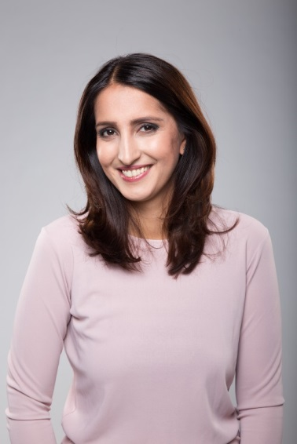  © nasima.fi | Nasima Razmyar  Nasima Razmyar is a Finnish Member of Parliament and Member of the City Council of Helsinki. She is also involved in many non-governmental organizations such as MONIKA – Multicultural Women’s Association and the Finnish Settlement Movement, an organization working towards a multicultural Finland.  Ms Razmyar was born in Afghanistan but due to regime change in 1992 she had to seek refuge in Finland. In spring 2015 she was elected into parliament as first female refugee. During this term she worked in both the Education and Culture Committee and the Environment Committee.
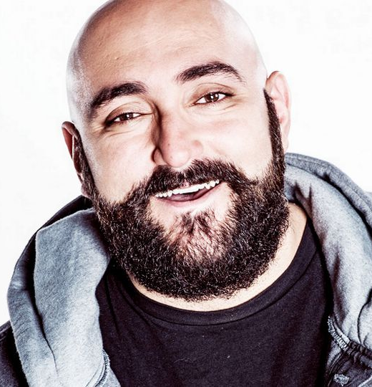  © YLE | Ali Jahangiri  Mr Jahangiri is an Iranian born radio presenter and stand-up comedian. As a comedian, he earned a reputation as a political satirist. Mr Jahangiri also hosted Finland’s Reality Queens of the Jungle, and is hosting his own talk show on Finnish national radio Yle. As a journalist living in Finland, he also followed the journey of refugees from Syria to Europe.
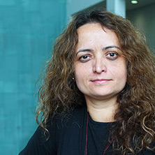  © City University London | Dr Carolina Matos  Dr Carolina Matos is a journalist, Lecturer in Sociology and researcher at the City University London. She has 23 years of professional experience; 10 years as a full-time journalist in Brazil and over 12 years working in universities throughout the UK.  During the last 13 years, Dr Matos has been teaching in the areas of media and democracy, political communications, international relations and the media, political economy of the media and globalisation and, the mass media. Her research is situated in the areas of comparative political communications, media and democracy, globalization and development, international communications and journalism.
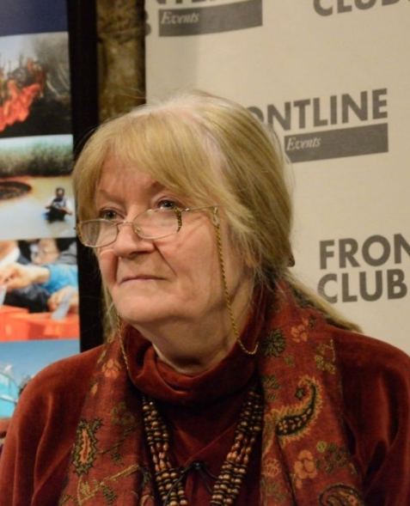  © Richard Nield | Dr Naomi Sakr  Naomi Sakr is Professor of Media Policy at the Communication and Media Research Institute (CAMRI), University of Westminster, and a former Director of the CAMRI Arab Media Centre.  She was previously a journalist, editor and country analyst. She worked at the Economist Intelligence Unit (1985-97) as a Middle East specialist and managing editor of political risk and economic forecast reports.  Professor Sakr is the author of Transformations in Egyptian Journalism, and has written and edited several other books on Arab media. She is currently leading a research project on screen media for Arabic-speaking children.
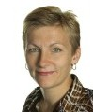  © LinkedIn | Charlotte Harder  International Editor, Danish Broadcasting Corporation  Charlotte Harder is the Managing editor at the foreign desk in the news department of the Danish Broadcasting Corporation.  Before, she worked for 3 years as a reporter in Washington DC, covering US politics, economics and life. She also used to be a EU correspondent, spending 5 years in Brussels.  Before joining the Danish Broadcasting Corporation, she has been working for the Danish news agency Ritzau, the leading newspaper Berlingske Tidende and the Danish TV channel – TV2.
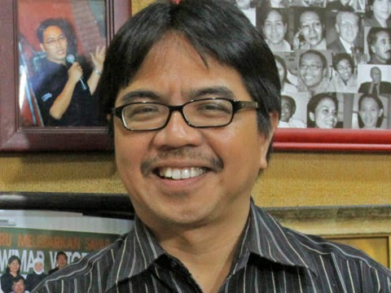  © Riset | Dr Ade Armando  Ade Armando is a communication expert, TV host and Associate Professor at the University of Indonesia where he used to serve as the Director of Development of Television Journalism Training Program. He is currently a researcher on mass communication issues in Saiful Mujani Research and Consulting (SMRC). Ade has taught at several other universities. Ade is also actively engaged in promoting pluralism and minority rights in Indonesia. He is currently a chief editor of Madina, an online media which focuses its attention on criticizing Islamic radicalism and defending Islamic pluralism. He was a commissioner of the Indonesian Broadcasting Commission and a journalist working for the Indonesian Islamic newspaper, Republika. For several years he also hosted a pay-tv talkshow program on Islamic issues in Indonesia.
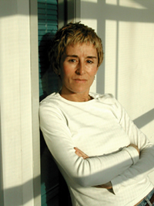  ©MDI | Milica Pesic  Milica Pesic is Executive Director of the Media Diversity Institute (MDI), a London-based international organisation specialized in inclusion of diversity through media and media education. Milica has designed and supervised multi-national, multi-annual diversity media development programmes in Europe, NIS, MENA, SEA, Sub-Sahara, West Africa and The Caribbean. Journalist by profession she has reported for the BBC, Radio Free Europe, the Times HES, and TV Serbia. Milica has also worked for New York University, the International Federation of Journalists (Brussels), and the AIM (Paris). She has co-designed an MA course in Media and Diversity taught at the University of Westminster UK). She has provided media training for the UN, Council of Europe, UNICEF, OSI, EBDR, Internews, Freedom Forum and the IFJ.

