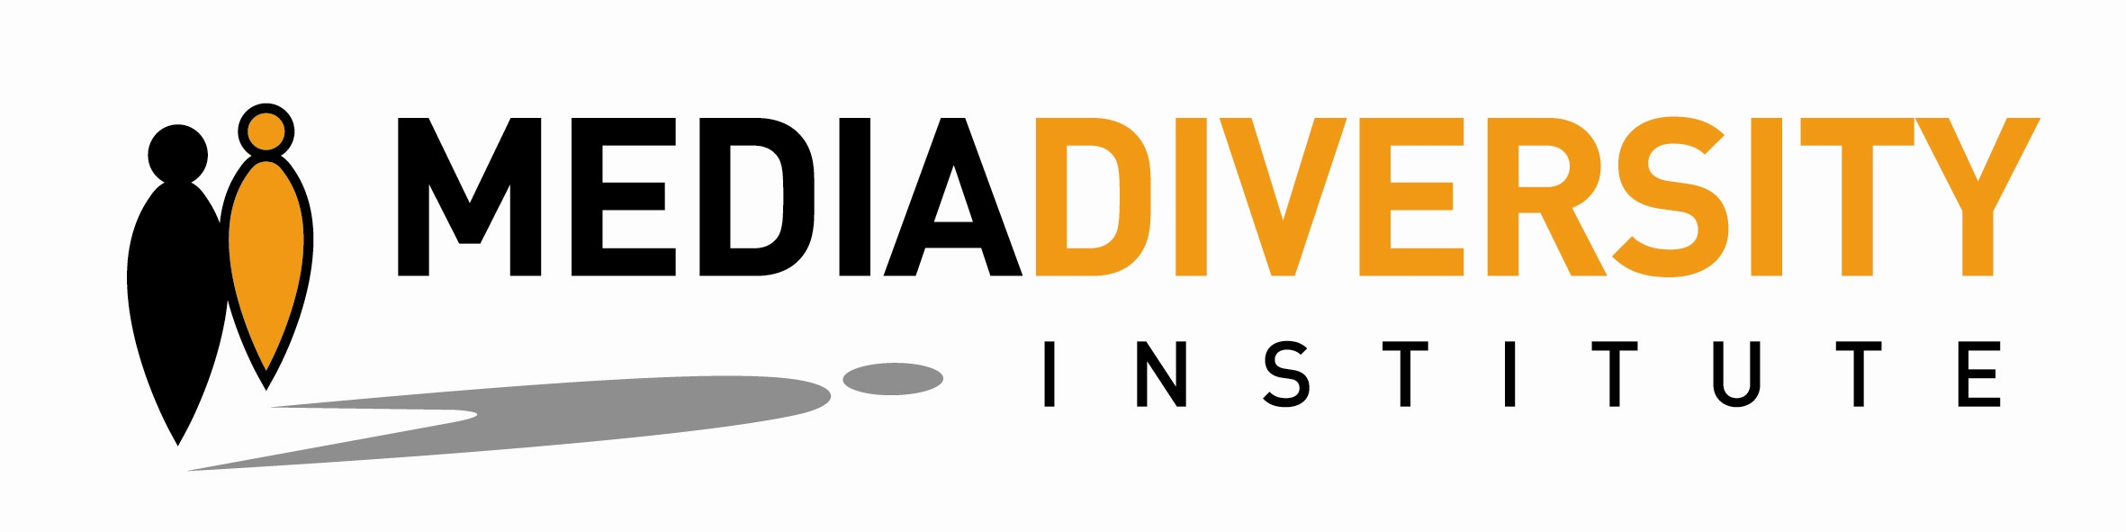

Application Form
Free Media Relations Workshop, 25-27 October 2013, London

Name of your organisation:
Address of your organisation:
In which countries does your organisation work?
Name of representative of the organisation that will attend the workshop (only 1 person can attend):
What is the representative’s job title?
Is the representative a member of the vulnerable/minority groups that your organisation represents?
Contact telephone number of representative:
Email address of representative:
How many full-time staff does the organisation employ?
How many part-time staff & volunteers does the organisation employ?
Does the organisation have a member of staff who is responsible for media relations/communications either full or part-time?

Which vulnerable/minority group(s) does your organisation represent?

Briefly explain the types of work your organisation does:

How often does your organisation communicate with the media (never, occasionally, frequently)?

Does your organisation have a strategy of engagement with the media? If so, please give brief details.

Has your organisation ever produced a press release?

Please briefly give examples of previous engagement with the media, if any:

What problems or issues has your organisation encountered while working with the media, if any?

Does your organisation want to/need to engage more with the media and if so, why?

Has your organisation had media relations training before? If so, please give brief details.

Does your organisation need media relations training? If so, please explain why.

Please return completed form to: lorena.martinez@media-diversity.org

Deadline for applications is 6 October 2013

