 Media Diversity Institute

MIRRORING IMAGES:

ETHNIC MINORITIES IN THE SOUTH EAST EUROPEAN PRESS

Media Diversity Institute
Dr Snjezana Milivojevic, author

RESEARCH FINDINGS

BOOK OF CHARTS

HOW TO READ THE CHARTS

The following tables and charts present findings from the monitoring. These tables and charts are organized according to the qualities of the analyzed articles. The first section contains comparative data about the entire region and the second presents data by countries.

There are 1604 analyzed items, and where the amount of items is concerned, this is the number referred to as the total. An item is a newspaper text selected as an unit of analysis. It is an article with it’s headlines and photographs belonging to it - a body of text and visuals distinguishable from the rest of the newspaper by its distinct content and graphics, regardless of its journalistic genre or placement. Values are always expressed in absolute numbers in the column ‘No’ and percentages in the column ‘%.’

Items were selected for analysis when they were about a particular ethnic minority, minorities in general, or if their topic was directly related to minority issues: legal changes, minority policies, debate about discrimination, etc. Ethnic minorities in an article is called actors. There were stories with two different actors, so their total exceeds the number of items at 1948. In tables and graphs about actors, this is the number referred to as the total.

Content were classified under four major blocks of topics that were defined as most frequent, based on a pilot study. Each of these blocks contain several possible issues providing for further classification of the content variety. As there were articles dealing with more than one issue, the number of topics is also larger than the number of items, 1684, and this number is the total when topic qualities are presented.
ETHNIC MINORITIES COVERAGE IN THE REGION

Sheet 1: AMOUNT OF COVERAGE: COUNTRIES -- total number of items in the region, their number and percentage by countries.

Sheet 2: AMOUNT OF COVERAGE: NEWSPAPERS -- total number of items in the region and distribution of items by the newspapers in each country.

Sheet 3: HEADLINES: RELATION TO THE TEXT-- presents whether there is a headline or not, and how directly it relates to the content.

Sheet 4: HEADLINES: TYPE -- differentiates between groups of descriptive or informative and discriminatory or sensational headlines.

Sheet 5-10: DISCRIMINATORY HEADLINES -- presents their amount and percentage by countries, article types, salience, topics, actors, and framing of the articles.

Sheet 11: SECTION OF THE NEWSPAPER -- where the article is placed. Broad classification was suggested because of wide variety in newspaper standards around the region.

Sheet 12-14: Amount of articles announced in the front page, and amount of front and foreign page articles by countries.

Sheet 15: ITEM TYPES -- articles classified according to their news quality as briefs (only very short stories), news stories, various feature articles (including interviews, reportage, analysis, etc.) editorials and letters to the editor.

Sheet 16-18: Amount and percentage of feature, editorial and letters to the editor by countries.

Sheet 19: SALIENCE OF THE ITEMS -- classified on a 5-point scale as very long, long, medium, short and very short. Length was determined according to the newspaper’s standards and after a medium was established at about one quarter of the page. Small was less than a quarter; briefs are very small; long is around half a page and very long is everything between a half and full page.

Sheet 20: FOCUS OF THE ITEMS -- on the importance of a minority issue actor for the entire content. When it was the primary concern of the article it was classified as the main focus, but if it was on some other issue then as secondary or as related when it was only remotely relevant to the content.

Sheet 21- 22: VISUAL PRESENTATION -- refers to various visuals as part of the article. These include photographs, illustrations, sketches, drawings, comics, graphics, data, tables, or maps.
An individual was only coded when it was a visual of an individual from the minority group. Crowds are groups of people. Landscape and maps is an object. Other are any individual not from the specified minority group such as author of the text, or other source.

Sheet 23: PHOTOGRAPHS -- same classification.

Sheet 24-28: TOPICS OF THE ITEMS -- presents percentages of four major topic groups: conflict, minority policy, everyday life, and ethnic issues in the region, in the total amount of topics. They do not correspond to the number of items as some had more than one topic.

Sheet 25-28: Detailed classification of topics in each group with the amount and percentage for each.

Sheet 29-30: ETHNIC MINORITIES AS ACTORS -- presents listings of all minority groups mentioned, those who attracted more coverage and major ethnic groups by the amount of coverage.

Sheet 31-33: ACTOR’S SOCIAL ROLES -- extensive listing of social roles of ethnic actors. Includes individual versus collective roles and the most frequently appearing social roles.

Sheet 34: ACTOR’S GENDER -- gender structure of minority actors. Female and male is coded only when individualised and identified with their gender. In all the other cases, when the whole ethnic minority was referred to, or even when the group probably consisted of all male actors as fighters, rebels, or police it was regarded as unspecified and therefore coded as other.

Sheet 35-39: FEMALE ACTORS -- and their appearance by countries, social roles, section of the newspaper, generalization of their activity and defining role.

Sheet 41: GENERALIZATION OF ACTOR’S ACTIVITY -- refers to the presentation of activity as an individual occurrence, or typical for some larger group, which could be the military, professional, or disabled people, or generalized to cover the whole ethnic group or all minorities.

Sheet 42: ACTOR’S DEFINING ROLE -- indicates how active or passive in defining the event is the actor. Either they define the event, or they are defined by some other actor.

Sheet 43: ACTOR’S VOICE -- represents how often the actor is quoted, paraphrased or simply related to by others.

Sheet 44: FRAMING OF THE ITEMS -- refers to the newspaper’s general approach to the article. Five frames were singled out as the most relevant after the pilot study.

Sheet 45-50: DISCRIMINATORY FRAMING -- and its distribution by countries, actors, headlines, salience, section and item topics.

ETHNIC MINORITIES COVERAGE PER COUNTRIES

Following charts are presented by countries:

1. ETHNIC MINORITIES AS ACTORS
2. MAJOR ETHNIC ACTORS
3. TOPICS OF THE ITEMS
4. DOMINANT TOPICS

ETHNIC MINORITIES COVERAGE IN THE REGION

1. amount of coverage: items per countries bookmark01
2. amount of coverage: items per newspapers
3. headlines: relation to the text
4. headlines: type

5. discriminatory headlines: countries bookmark1
6. discriminatory headlines: actors
7. discriminatory headlines: section
8. discriminatory headlines: salience
9. discriminatory headlines: topic
10. discriminatory headlines: framing

11. section of the items: front page
12. section of the items: foreign page

13. type of the items: feature
14. type of the items: editorial
15. type of the items: letter

16. salience of the items bookmark2
17. focus of the items
18. visual presentation: type
19. visual presentation: content
20. visual presentation: photographs

21. topics of the items
22. topic of the item: conflict
23. topic of the item: minority policy
24. topic of the item: everyday life
25. topic of the item: ethnic issues in the region

26. ethnic minorities as actors bookmark3
27. major ethnic actors
28. actor’s social roles
29. individual vs. collective roles
30. collective social roles
31. actor’s gender
32. female actors: countries
33. female actors: social roles
34. female actors: section
35. female actors: generalization
36. female actors: defining role

37. generalization of actor’s activity bookmark4
38. actor’s defining role
39. actor’s voice

40. framing of the items
41. discriminatory framing: countries
42. discriminatory framing: actors
43. discriminatory framing: headlines
44. discriminatory framing: salience
45. discriminatory framing: section
46. discriminatory framing: topics

ETHNIC MINORITIES COVERAGE PER COUNTRIES

Albania
1. ethnic minorities as actors bookmark5
2. major ethnic actors
3. topics of the items
4. topic: ethnic issues in the region

Bosnia and Herzegovina
1. ethnic minorities as actors
2. major ethnic actors
3. topics of the items
4. topic: ethnic issues in the region
5. topic: minority policy

Bulgaria
1. ethnic minorities as actors BOOMARK6
2. major ethnic actors
3. topics of the items
4. topic: everyday life

Croatia
1. ethnic minorities as actors
2. major ethnic actors
3. topics of the items
4. topic: ethnic issues in the region
5. topic: minority policy

Hungary BOOKMARK7
1. ethnic minorities as actors
2. major ethnic actors
3. topics of the items
4. topic: ethnic issues in the region
5. topic: everyday life

Kosovo
1. major ethnic actors BOOKMARK8
2. topics of the items
3. topic: conflict

Macedonia
1. ethnic minorities as actors
2. major ethnic actors
3. topics of the items
4. topic: conflict

Montenegro
1. ethnic minorities as actors
2. major ethnic actors
3. topics of the items

Romania
1. ethnic minorities as actors
2. major ethnic actors
3. topics of the items
4. topic: conflict
5. topic: everyday life

Serbia
1. ethnic minorities as actors
2. major ethnic actors
3. topics of the items
4. topic: conflict

1. AMOUNT OF COVERAGE : COUNTRIES

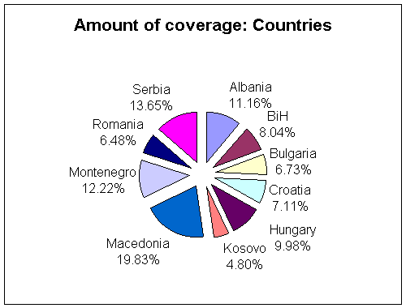

COUNTRY | ITEMS | %
Albania | 179 | 11.16
BiH | 129 | 8.04
Bulgaria | 108 | 6.73
Croatia | 114 | 7.11
Hungary | 160 | 9.98
Kosovo | 77 | 4.8
Macedonia | 318 | 19.83
Montenegro | 196 | 12.22
Romania | 104 | 6.48
Serbia | 219 | 13.65
TOTAL | 1604 | 100

Daily average: 53.47
Weekly average: 401
A NOTE: An item is an article and its accompanying headlines, photographs and graphics, making up a distinct body of material, (regardless of its journalistic genre or place in the newspaper).

back

2. AMOUNT OF COVERAGE: NEWSPAPERS

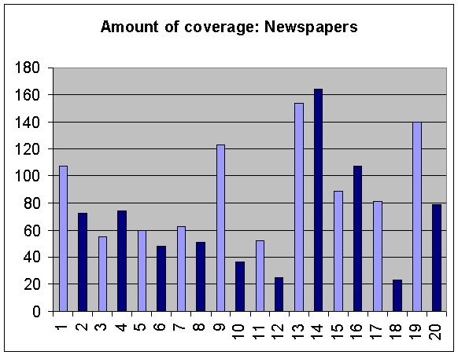

Country | Papers | Items | Papers | Items | Total
Albania | Albania (1) | 107 | Shekulli (2) | 72 | 179
BiH | Dnevni avaz (3) | 55 | Nezavisne (4) | 74 | 129
Bulgaria | Trud (5) | 60 | 24 casa (6) | 48 | 108
Croatia | Jutarnji (7) | 63 | Vecernji (8) | 51 | 114
Hungary | Nepsabadsag (9) | 123 | Metro (10) | 37 | 160
Kosovo | Koha ditore (11) | 52 | Bota sot (12) | 25 | 77
Macedonia | Dnevnik (13) | 154 | Utrinski (14) | 164 | 318
Montenegro | Vjesti (15) | 89 | Dan (16) | 107 | 196
Romania | Adevarul (17) | 81 | Libertatea (18) | 23 | 104
Serbia | Politika (19) | 140 | Blic (20) | 79 | 219
Total |  |  |  |  | 1604

A NOTE: An item is an article and its accompanying headlines, photographs and graphics, making up a distinct body of material, (regardless of its journalistic genre or place in the newspaper).

back

3. HEADLINES: RELATION TO THE TEXT

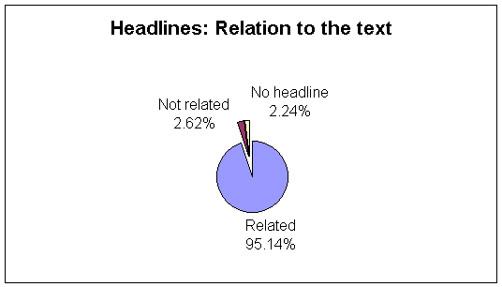

HEADLINES | ITEMS | %
Related | 1526 | 95.14%
Not related | 42 | 2.62%
No headline | 36 | 2.24%
TOTAL | 1604 | 100%

A NOTE: An item is an article and its accompanying headlines, photographs and graphics, making up a distinct body of material, (regardless of its journalistic genre or place in the newspaper).

back
4. HEADLINES: TYPE

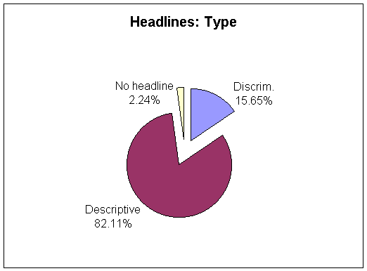

HEADLINES | ITEMS | %
Discriminatory | 251 | 15.65
Descriptive | 1317 | 82.11
No headline | 36 | 2.24
TOTAL | 1604 | 100%

A NOTE: An item is an article and its accompanying headlines, photographs and graphics, making up a distinct body of material, (regardless of its journalistic genre or place in the newspaper).

back
5. DISCRIMINATORY HEADLINES: COUNTRIES

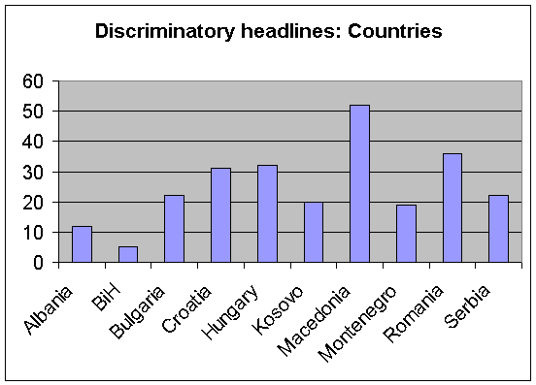

COUNTRY | ITEMS | %
Albania | 12 | 4.78
BiH | 5 | 2
Bulgaria | 22 | 8.76
Croatia | 31 | 12.35
Hungary | 32 | 12.75
Kosovo | 20 | 7.97
Macedonia | 52 | 20.72
Montenegro | 19 | 7.57
Romania | 36 | 14.34
Serbia | 22 | 8.76
TOTAL | 251 | 100

A NOTE: An item is an article and its accompanying headlines, photographs and graphics, making up a distinct body of material, (regardless of its journalistic genre or place in the newspaper).

back
6. DISCRIMINATORY HEADLINES: ACTORS

ACTORS | ITEMS | %
Serbs (Fed)/5 | 3 | 0.98
Croats (Fed)/6 | 2 | 0.65
Bosniacs (RS)/7 | 2 | 0.65
Roma (BG)/19 | 9 | 2.91
Turks (BG)/20 | 5 | 1.62
Serbs (Cro)/21 | 25 | 8.09
Hungarians (Cro)/24 | 1 | 0.32
Italians (Cro)/25 | 1 | 0.32
Roma (Cro)/27 | 2 | 0.65
Jewish (Cro)/28 | 4 | 1.29
Roma (Hun)/29 | 10 | 3.24
Jewish (Hun)/40 | 4 | 1.29
Albanians (Kos)/41 | 27 | 8.74
Serbs (Kos)/43 | 48 | 15.53
Roma (Kos)/44 | 1 | 0.32
Roma (Mac)/47 | 3 | 0.98
Albanians (Mac)/53 | 91 | 29.45
Albanians (MN)/54 | 2 | 0.65
Bosniacs/Muslims (MN)/58 | 2 | 0.65
Hungarians (Ro)/61 | 26 | 8.41
Roma (Ro)/62 | 19 | 6.15
Armenians (Ro)/74 | 2 | 0.65
Croats (Ro)/76 | 1 | 0.32
Albanians (Ser)/77 | 2 | 0.65
Hungarians (Ser)/78 | 1 | 0.32
Roma (Ser)/81 | 1 | 0.32
Other/99 | 15 | 4.85
TOTAL+B7 | 309 | 100

A NOTE: An item is an article and its accompanying headlines, photographs and graphics, making up a distinct body of material, (regardless of its journalistic genre or place in the newspaper).

back
7. DISCRIMINATORY HEADLINES: SECTION

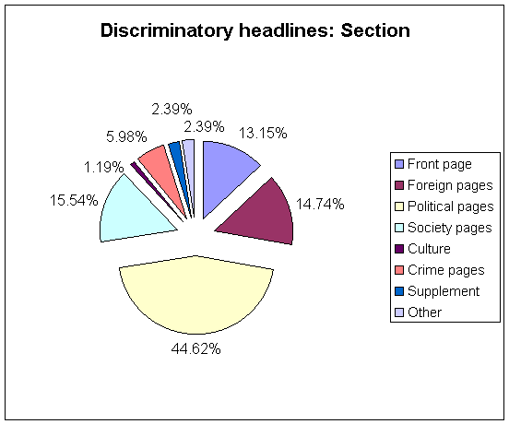

SECTION | ITEMS | %
Front page | 33 | 13.15
Foreign pages | 37 | 14.74
Political pages | 112 | 44.62
Society pages | 39 | 15.54
Culture | 3 | 1.19
Crime pages | 15 | 5.98
Supplement | 6 | 2.39
Other | 6 | 2.39
TOTAL | 251 | 100

A NOTE: An item is an article and its accompanying headlines, photographs and graphics, making up a distinct body of material, (regardless of its journalistic genre or place in the newspaper).

back
8. DISCRIMINATORY HEADLINES: SALIENCE

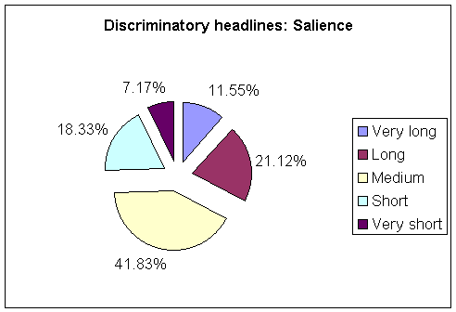

SALIENCE | ITEMS | %
Very long | 29 | 11.55
Long | 53 | 21.12
Medium | 105 | 41.83
Short | 46 | 18.33
Very short | 18 | 7.17
TOTAL | 251 | 100

A NOTE: An item is an article and its accompanying headlines, photographs and graphics, making up a distinct body of material, (regardless of its journalistic genre or place in the newspaper).

back

9. DISCRIMINATORY HEADLINES: TOPIC

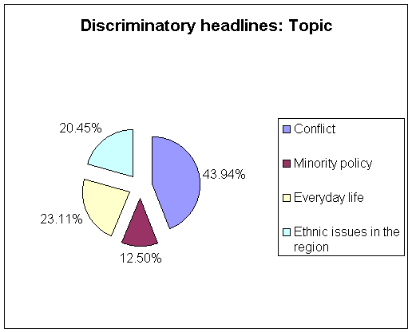

TOPIC | ITEMS | %
Conflict | 116 | 43.94
Minority policy | 33 | 12.5
Everyday life | 61 | 23.11
Ethnic issues in the region | 54 | 20.45
TOTAL | 264 | 100

A NOTE: An item is an article and its accompanying headlines, photographs and graphics, making up a distinct body of material, (regardless of its journalistic genre or place in the newspaper).

back

10. DISCRIMINATORY HEADLINES: FRAMING

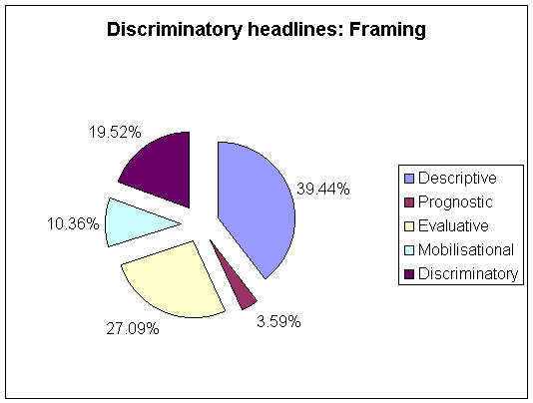

FRAMING | ITEMS | %
Descriptive | 99 | 39.44
Prognostic | 9 | 3.59
Evaluative | 68 | 27.09
Mobilisational | 26 | 10.36
Discriminatory | 49 | 19.52
TOTAL | 251 | 100

A NOTE: An item is an article and its accompanying headlines, photographs and graphics, making up a distinct body of material, (regardless of its journalistic genre or place in the newspaper).

back
11. SECTION: FRONT PAGE

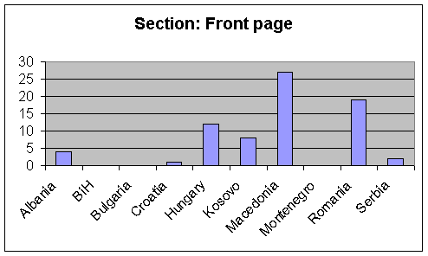

COUNTRY | Items | %
Albania | 4 | 5.48
BiH | 0 | 0
Bulgaria | 0 | 0
Croatia | 1 | 1.37
Hungary | 12 | 16.44
Kosovo | 8 | 10.96
Macedonia | 27 | 36.99
Montenegro | 0 | 0
Romania | 19 | 26.03
Serbia | 2 | 2.73
Total | 73 | 100

A NOTE: An item is an article and its accompanying headlines, photographs and graphics, making up a distinct body of material, (regardless of its journalistic genre or place in the newspaper).

back
12. SECTION: FOREIGN PAGE

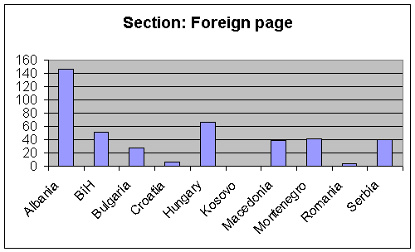

COUNTRY | Items | %
Albania | 146 | 34.76
BiH | 51 | 12.14
Bulgaria | 27 | 6.43
Croatia | 6 | 1.43
Hungary | 66 | 15.71
Kosovo | 0 | 0
Macedonia | 39 | 9.29
Montenegro | 41 | 9.76
Romania | 4 | 0.95
Serbia | 40 | 9.53
Total | 420 | 100

A NOTE: An item is an article and its accompanying headlines, photographs and graphics, making up a distinct body of material, (regardless of its journalistic genre or place in the newspaper).

back
13. TYPE OF THE ITEMS: FEATURE

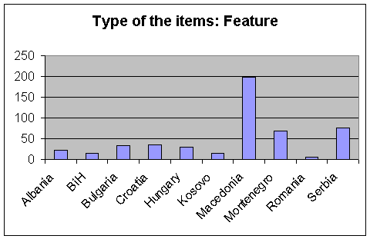

COUNTRY | ITEMS | %
Albania | 23 | 4.59
BiH | 15 | 2.99
Bulgaria | 33 | 6.59
Croatia | 36 | 7.19
Hungary | 30 | 5.99
Kosovo | 15 | 2.99
Macedonia | 199 | 39.72
Montenegro | 68 | 13.57
Romania | 6 | 1.2
Serbia | 76 | 15.17
TOTAL | 501 | 100

A NOTE: An item is an article and its accompanying headlines, photographs and graphics, making up a distinct body of material, (regardless of its journalistic genre or place in the newspaper).

back
14. TYPE OF THE ITEMS: EDITORIAL

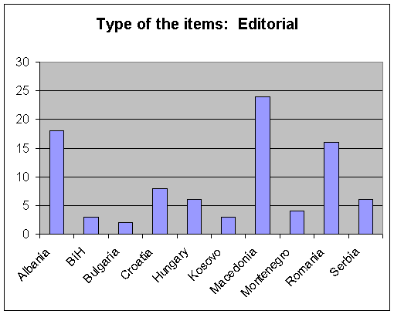

COUNTRY | ITEMS | %
Albania | 18 | 20
BiH | 3 | 3.33
Bulgaria | 2 | 2.22
Croatia | 8 | 8.89
Hungary | 6 | 6.67
Kosovo | 3 | 3.33
Macedonia | 24 | 26.67
Monte Negro | 4 | 4.44
Romania | 16 | 17.78
Serbia | 6 | 6.67
TOTAL | 90 | 100

A NOTE: An item is an article and its accompanying headlines, photographs and graphics, making up a distinct body of material, (regardless of its journalistic genre or place in the newspaper).

back
15. TYPE OF THE ITEMS: LETTER

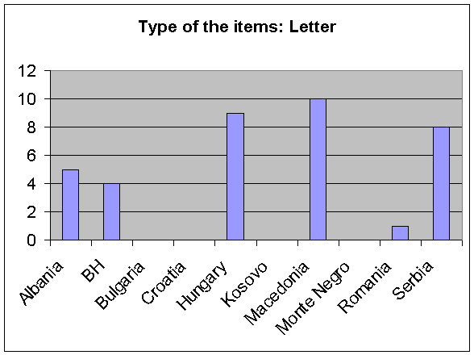

COUNTRY | ITEMS | %
Albania | 5 | 13.51
BH | 4 | 10.81
Bulgaria | 0 | 0
Croatia | 0 | 0
Hungary | 9 | 24.32
Kosovo | 0 | 0
Macedonia | 10 | 27.04
Monte Negro | 0 | 0
Romania | 1 | 2.7
Serbia | 8 | 21.62
TOTAL | 37 | 100

A NOTE: An item is an article and its accompanying headlines, photographs and graphics, making up a distinct body of material, (regardless of its journalistic genre or place in the newspaper).

back
16. SALIENCE OF THE ITEMS

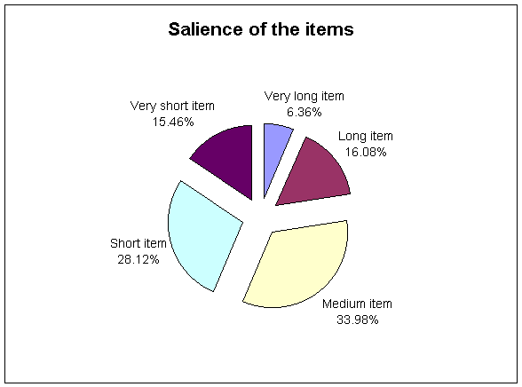

SALIENCE | ITEMS | %
Very long item | 102 | 6.36
Long item | 258 | 16.08
Medium item | 545 | 33.98
Short item | 451 | 28.12
Very short item | 248 | 15.46
TOTAL | 1604 | 100

A NOTE: An item is an article and its accompanying headlines, photographs and graphics, making up a distinct body of material, (regardless of its journalistic genre or place in the newspaper).

back
17. FOCUS OF THE ITEMS

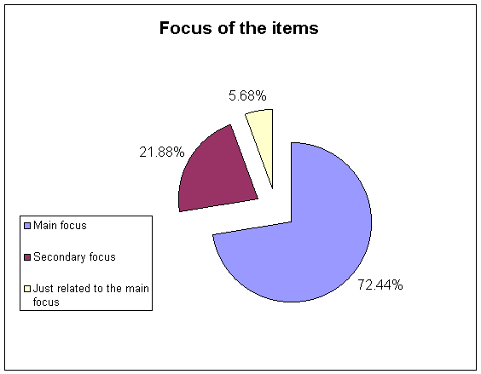

FOCUS | ITEMS | %
Main focus | 1162 | 72.44
Secondary focus | 351 | 21.88
Just related to the main focus | 91 | 5.68
TOTAL | 1604 | 100

A NOTE: An item is an article and its accompanying headlines, photographs and graphics, making up a distinct body of material, (regardless of its journalistic genre or place in the newspaper).

back
18. VISUAL PRESENTATION: TYPE

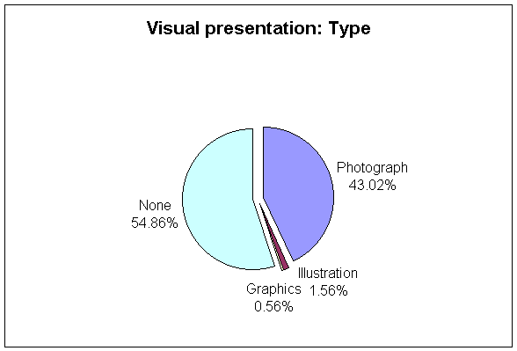

VP: TYPE | ITEMS | %
Photograph | 690 | 43.02
Illustration | 25 | 1.56
Graphics | 9 | 0.56
None | 880 | 54.86
TOTAL | 1604 | 100

A NOTE: An item is an article and its accompanying headlines, photographs and graphics, making up a distinct body of material, (regardless of its journalistic genre or place in the newspaper).

back
19. VISUAL PRESENTATION : CONTENT

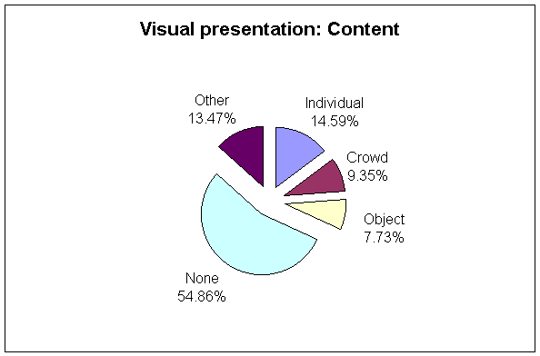

VP: CONTENT | ITEMS | %
Individual | 234 | 14.59
Crowd | 150 | 9.35
Object | 124 | 7.73
None | 880 | 54.86
Other | 216 | 13.47
TOTAL | 1604 | 100

A NOTE: An item is an article and its accompanying headlines, photographs and graphics, making up a distinct body of material, (regardless of its journalistic genre or place in the newspaper).

back
20. VISUAL PRESENTATION : PHOTOGRAPHS

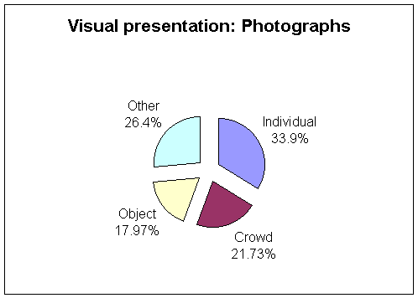

PHOTOGRAPHS | ITEMS | %
Individual | 234 | 33.9
Crowd | 150 | 21.73
Object | 124 | 17.97
Other | 182 | 26.4
TOTAL | 690 | 100

A NOTE: An item is an article and its accompanying headlines, photographs and graphics, making up a distinct body of material, (regardless of its journalistic genre or place in the newspaper).

back
21. TOPICS OF THE ITEMS

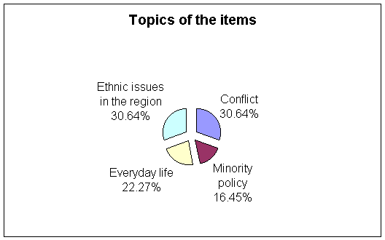

Topic | ITEMS | %
Conflict | 516 | 32.17
All items | 1604 | 100
Topic | Items | %
Minority policy | 277 | 17.27
All items | 1604 | 100
Topic | Items | %
Everyday life | 375 | 23.38
All items | 1604 | 100
Topic | Items | %
Ethnic issues in the region | 516 | 32.17
TOTAL ITEMS | 1604 | 100

TOPICS | ITEMS | %
Conflict | 516 | 30.64
Minority policy | 277 | 16.45
Everyday life | 375 | 22.27
Ethnic issues in the region | 516 | 30.64
TOTAL TOPICS | 1684 | 100

A NOTE: An item is an article and its accompanying headlines, photographs and graphics, making up a distinct body of material, (regardless of its journalistic genre or place in the newspaper).

back
22. TOPIC OF THE ITEMS: CONFLICT

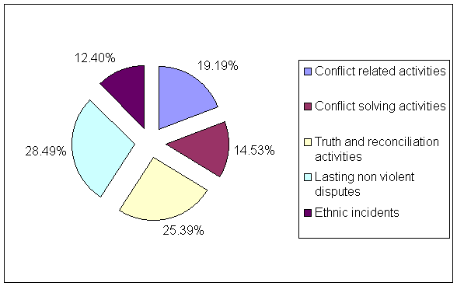

TOPIC | ITEMS | %
Conflict related activities | 99 | 19.19
Conflict solving activities | 75 | 14.53
Truth and reconciliation activities | 131 | 25.39
Lasting non violent disputes | 147 | 28.49
Ethnic incidents | 64 | 12.4
TOTAL | 516 | 100

A NOTE: An item is an article and its accompanying headlines, photographs and graphics, making up a distinct body of material, (regardless of its journalistic genre or place in the newspaper).

back
23. TOPIC OF THE ITEMS: MINORITY POLICY

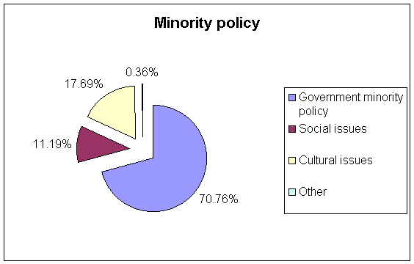

TOPIC | ITEMS | %
Government minority policy | 196 | 70.76
Social issues | 31 | 11.19
Cultural issues | 49 | 17.69
Other | 1 | 0.36
TOTAL | 277 | 100

A NOTE: An item is an article and its accompanying headlines, photographs and graphics, making up a distinct body of material, (regardless of its journalistic genre or place in the newspaper).

back
24. TOPIC OF THE ITEMS: EVERYDAY LIFE

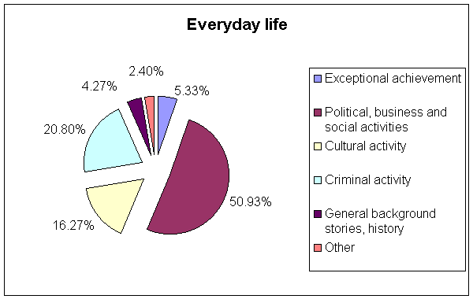

TOPIC | ITEMS | %
Exceptional achievement | 20 | 5.33
Political, business and social activities | 191 | 50.93
Cultural activity | 61 | 16.27
Criminal activity | 78 | 20.8
General background stories, history | 16 | 4.27
Other | 9 | 2.4
TOTAL | 375 | 100

A NOTE: An item is an article and its accompanying headlines, photographs and graphics, making up a distinct body of material, (regardless of its journalistic genre or place in the newspaper).

back
25. TOPIC OF THE ITEMS: ETHNIC ISSUES IN THE REGION

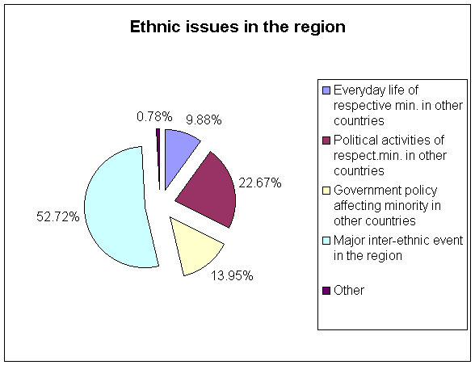

TOPIC | ITEMS | %
Everyday life of respective min. in other countries | 51 | 9.88
Political activities of respect.min. in other countries | 117 | 22.67
Government policy affecting minority in other countries | 72 | 13.95
Major inter-ethnic event in the region | 272 | 52.72
Other | 4 | 0.78
TOTAL | 516 | 100

A NOTE: An item is an article and its accompanying headlines, photographs and graphics, making up a distinct body of material, (regardless of its journalistic genre or place in the newspaper).

back

26. ETHNIC MINORITIES AS ACTORS
ALL ACTORS |  | ITEMS
Macedonians AL |  | 2
Montenegrins AL |  | 3
Roma AL |  | 2
Serbs FED |  | 12
Croats FED |  | 37
Bosniacs RS |  | 19
Croats RS |  | 10
Roma BIH |  | 8
Czechs BIH |  | 2
Poles BIH |  | 1
Roma BG |  | 29
Turks BG |  | 55
Serbs CR |  | 94
Muslims CR |  | 2
Hungarians CR |  | 3
Italians CR |  | 4
Roma CR |  | 4
Jewish CR |  | 10
Roma HU |  | 46
Germans HU |  | 1
Romanians HU |  | 2
Croats HU |  | 3
Greeks HU |  | 2
Bulgarians HU |  | 2
Armenians HU |  | 1
Jewish HU |  | 13
Albanians KOS |  | 214
Montenegrins KOS |  | 1
Serbs KOS |  | 332
Roma KOS |  | 11
Roma MAC |  | 36
Vlahs MAC |  | 3
Serbs MAC |  | 8
Bosniacs/Muslims MAC |  | 1
Egyptians MAC |  | 1
Albanians MAC |  | 535
Albanians MN |  | 24
Serbs MN |  | 2
Roma MN |  | 10
Bosniacs/Muslims MN |  | 32
  A NOTE: An item is an article and its accompanying headlines, photographs and graphics, making up a distinct body of material, (regardless of its journalistic genre or place in the newspaper).
Hungarians RO |  | 89
Roma RO |  | 33
Turks RO |  | 2
Tartars RO |  | 2
Armenians RO |  | 5
Croats RO |  | 1
Albanians SER |  | 23
Hungarians SER |  | 6
Bosniacs/Muslims SER |  | 10
Roma SER |  | 9
Jewish SER |  | 2
Other |  | 189
TOTAL |  | 1948
OTHER ACTORS | ITEMS
Albanians | 11
Balkan minorities | 1
BG minorities | 1
BiH minorities | 9
Bosniacs in Kosovo | 4
Czechs | 1
CRO minorities | 1
Croats | 13
Csango | 2
FRY minorities | 8
Hungarians | 35
Kosovo minorities | 40
Gora in Kosovo | 1
Macedonians | 1
MAC minorities | 7
Minorities in general | 23
Montenegrins | 8
Moslems in BiH | 3
Muslims in MAC | 1
RO minorities | 2
Romanians | 1
RS min/ref/ret | 6
Russians | 1
SER minorities | 3
Serbs | 6
TOTAL | 189

A NOTE: An item is an article and its accompanying headlines, photographs and graphics, making up a distinct body of material, (regardless of its journalistic genre or place in the newspaper).

back
27. MAJOR ETHNIC ACTORS

MAJOR ACTORS | ITEMS
Roma | 188
Albanians | 807
Serbs | 454
Hungarians | 133
Bosniacs/Muslims | 72
Croats | 64
Turks | 57
Kosovo minorities | 40
Minorities in general | 23
Jewish | 25
Total | 1863
ALL ACTORS | ITEMS
Roma | 188
Albanians | 807
Armenians | 6
Bosniacs/Muslims | 72
Bulgarians | 2
Czechs | 3
Croats | 64
Egyptians | 1
Germans | 1
Greeks | 2
Hungarians | 133
Italians | 4
Jewish | 25
Macedonians | 3
Montenegrins | 12
Poles | 1
Romanians | 3
Serbs | 454
Tartars | 2
Turks | 57
Vlahs | 3
Balkan minorities | 1
BG minorities | 1
BiH minorities /RS | 15
CRO minorities | 1
Csango | 2
FRY minorities/SER | 11
Kosovo minorities | 40
Gora in Kosovo | 1
MAC minorities | 7
Minorities in general | 23
RO minorities | 2
Russians | 1
Total | 1948

OTHER ACTORS | ITEMS
Egyptians | 1
Germans | 1
Montenegrins | 12
Armenians | 6
Romanians | 3
Bulgarians | 2
Tartars | 2
Czechs | 3
Vlahs | 3
Balkan minorities | 1
BG minorities | 1
BiH minorities /RS | 15
CRO minorities | 1
Csango | 2
FRY minorities/SER | 11
Greeks | 2
Gora in Kosovo | 1
MAC minorities | 7
Italians | 4
RO minorities | 2
Russians | 1
Macedonians | 3
Poles | 1
Total | 85

A NOTE: An item is an article and its accompanying headlines, photographs and graphics, making up a distinct body of material, (regardless of its journalistic genre or place in the newspaper).

back
28. ACTOR'S SOCIAL ROLES

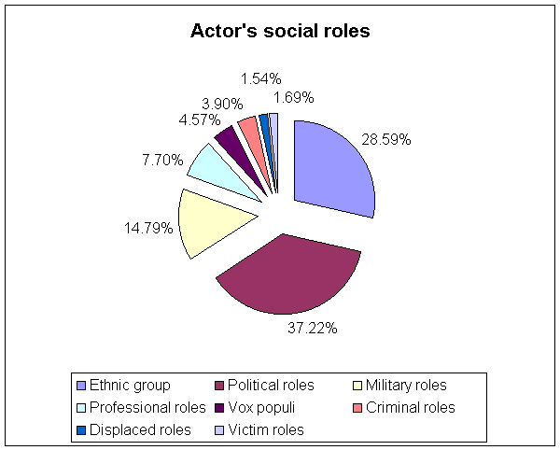

SOCIAL ROLES | ITEMS | %
Ethnic group | 557 | 28.59
Political roles | 725 | 37.22
Military roles | 288 | 14.79
Professional roles | 150 | 7.7
Vox populi | 89 | 4.57
Criminal roles | 76 | 3.9
Displaced roles | 30 | 1.54
Victim roles | 33 | 1.69
TOTAL | 1948 | 100

A NOTE: An item is an article and its accompanying headlines, photographs and graphics, making up a distinct body of material, (regardless of its journalistic genre or place in the newspaper).

back

29. INDIVIDUAL vs. COLLECTIVE SOCIAL ROLES

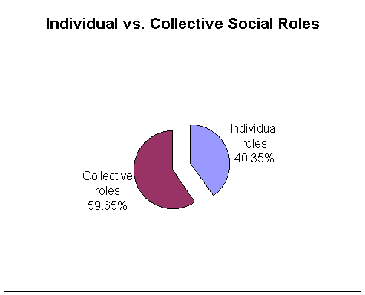

SOCIAL ROLES | Items | %
Individual roles | 786 | 40.35
Collective roles | 1162 | 59.65
Total | 1948 | 100

A NOTE: An item is an article and its accompanying headlines, photographs and graphics, making up a distinct body of material, (regardless of its journalistic genre or place in the newspaper).

back
30. COLLECTIVE SOCIAL ROLES
SOCIAL ROLES | Items
Business group | 7
Criminals | 12
Cultural group | 30
Displaced | 5
Emigrants | 1
Ethnic group | 557
Generals | 1
Multi-ethnic police | 6
Paramilitaries | 247
Parties | 131
Pol.org. | 15
Pol/fight | 12
Politicians | 73
Prisoners | 2
Professional group | 7
Refugees | 10
Relig.commun. | 8
Returnees | 14
Sport | 1
Victim group | 10
War criminals | 6
War victims | 7
Total | 1162

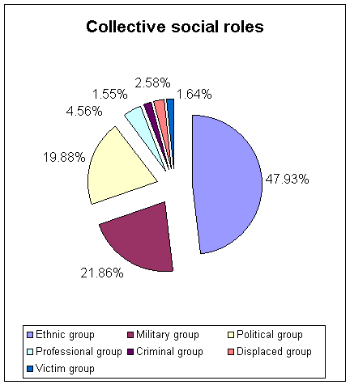

SOCIAL ROLES | Items | %
Ethnic group | 557 | 47.93
Military group | 254 | 21.86
Political group | 231 | 19.88
Professional group | 53 | 4.56
Criminal group | 18 | 1.55
Displaced group | 30 | 2.58
Victim group | 19 | 1.64
Total | 1162 | 100

A NOTE: An item is an article and its accompanying headlines, photographs and graphics, making up a distinct body of material, (regardless of its journalistic genre or place in the newspaper).

back
31. ACTOR'S GENDER

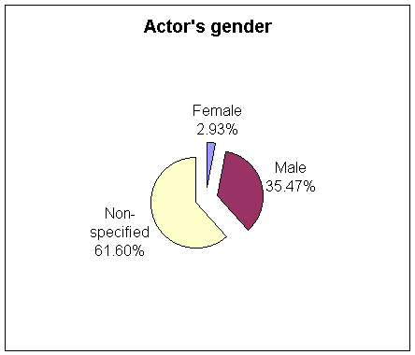

GENDER | Items | %
Female | 57 | 2.93
Male | 691 | 35.47
Non-specified | 1200 | 61.6
Total | 1948 | 100

A NOTE: An item is an article and its accompanying headlines, photographs and graphics, making up a distinct body of material, (regardless of its journalistic genre or place in the newspaper).

back
32. FEMALE ACTORS: COUNTRIES

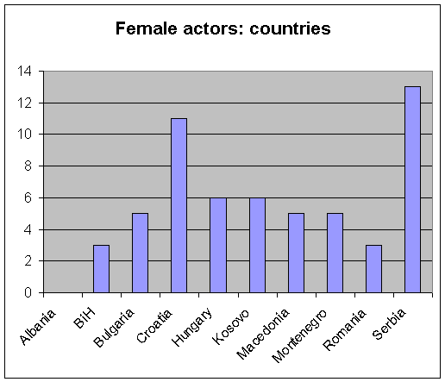

COUNTRY | Items | %
Albania | 0 | 0
BiH | 3 | 5.26
Bulgaria | 5 | 8.77
Croatia | 11 | 19.3
Hungary | 6 | 10.53
Kosovo | 6 | 10.53
Macedonia | 5 | 8.77
Montenegro | 5 | 8.77
Romania | 3 | 5.26
Serbia | 13 | 22.81
Total | 57 | 100

A NOTE: An item is an article and its accompanying headlines, photographs and graphics, making up a distinct body of material, (regardless of its journalistic genre or place in the newspaper).

back
33. FEMALE ACTORS: SOCIAL ROLES

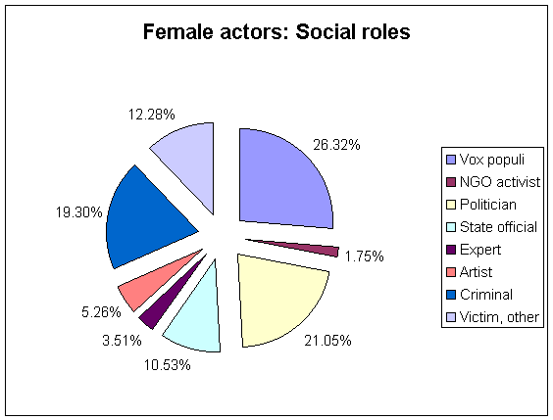

SOCIAL ROLES | Items | %
Vox populi | 15 | 26.32
NGO activist | 1 | 1.75
Politician | 12 | 21.05
State official | 6 | 10.53
Expert | 2 | 3.51
Artist | 3 | 5.26
Criminal | 11 | 19.3
Victim, other | 7 | 12.28
Total | 57 | 100

A NOTE: An item is an article and its accompanying headlines, photographs and graphics, making up a distinct body of material, (regardless of its journalistic genre or place in the newspaper).

back
34. FEMALE ACTORS: SECTION

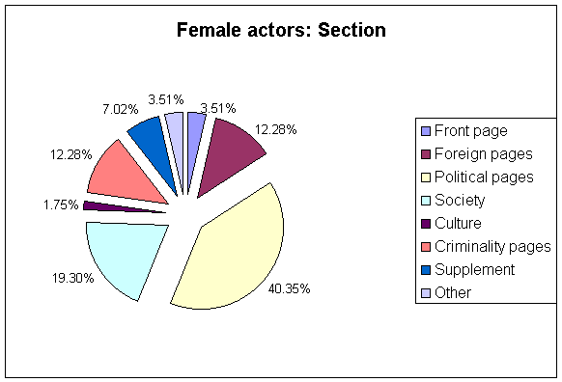

SOCIAL ROLES | Items | %
Vox populi | 15 | 26.32
NGO activist | 1 | 1.75
Politician | 12 | 21.05
State official | 6 | 10.53
Expert | 2 | 3.51
Artist | 3 | 5.26
Crime | 11 | 19.3
Victim, other | 7 | 12.28
Total | 57 | 100

A NOTE: An item is an article and its accompanying headlines, photographs and graphics, making up a distinct body of material, (regardless of its journalistic genre or place in the newspaper).

back
35. FEMALE ACTORS: GENERALISATION

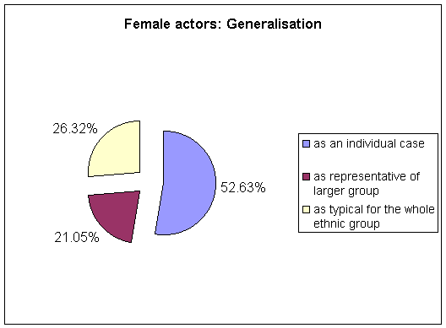

GENERALISATION | Items | %
as an individual case | 30 | 52.63
as representative of larger group | 12 | 21.05
as typical for the whole ethnic group | 15 | 26.32
Total | 57 | 100

A NOTE: An item is an article and its accompanying headlines, photographs and graphics, making up a distinct body of material, (regardless of its journalistic genre or place in the newspaper).

back
36. FEMALE ACTORS: DEFINING ROLE

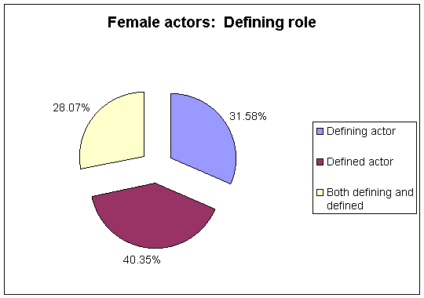

DEFINING ROLE | Items | %
Defining actor | 18 | 31.58
Defined actor | 23 | 40.35
Both defining and defined | 16 | 28.07
Total | 57 | 100

A NOTE: An item is an article and its accompanying headlines, photographs and graphics, making up a distinct body of material, (regardless of its journalistic genre or place in the newspaper).

back
37. GENERALISATION OF ACTOR'S ACTIVITY

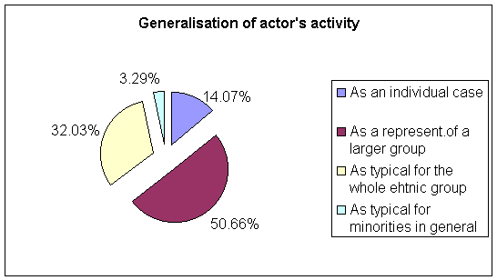

GENERALISATION | Items | %
As an individual case | 274 | 14.07
As represent.of a larger group | 986 | 50.66
As typical for the whole ethnic group | 624 | 32.03
As typical for minorities in general | 64 | 3.29
Total | 1948 | 100.05

A NOTE: An item is an article and its accompanying headlines, photographs and graphics, making up a distinct body of material, (regardless of its journalistic genre or place in the newspaper).

back
38. ACTOR'S DEFINING ROLE

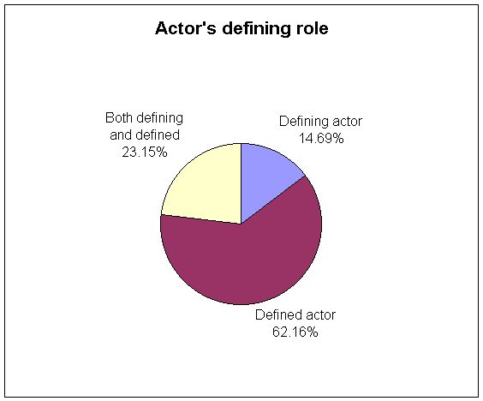

DEFINING ROLE | Items | %
Defining actor | 286 | 14.69
Defined actor | 1211 | 62.16
Both defining and defined | 451 | 23.15
Total | 1948 | 100

A NOTE: An item is an article and its accompanying headlines, photographs and graphics, making up a distinct body of material, (regardless of its journalistic genre or place in the newspaper).

back
39. ACTOR'S VOICE

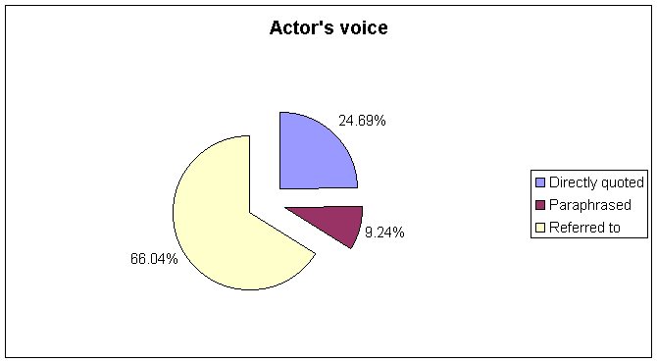

VOICE | Items | %
Directly quoted | 481 | 24.69
Paraphrased | 180 | 9.24
Referred to | 1287 | 66.04
Total | 1948 | 99.97

A NOTE: An item is an article and its accompanying headlines, photographs and graphics, making up a distinct body of material, (regardless of its journalistic genre or place in the newspaper).

back
40. FRAMING OF THE ITEMS

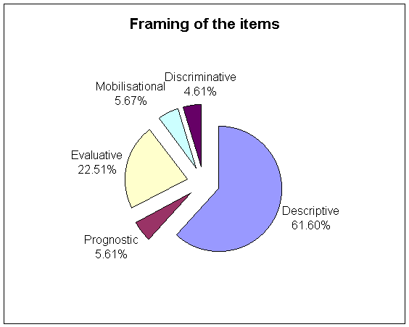

FRAMING | ITEMS | %
Descriptive | 988 | 61.6
Prognostic | 90 | 5.61
Evaluative | 361 | 22.51
Mobilisational | 91 | 5.67
Discriminatory | 74 | 4.61
TOTAL | 1604 | 100

A NOTE: An item is an article and its accompanying headlines, photographs and graphics, making up a distinct body of material, (regardless of its journalistic genre or place in the newspaper).

back
41. DISCRIMINATORY FRAMING: COUNTRIES

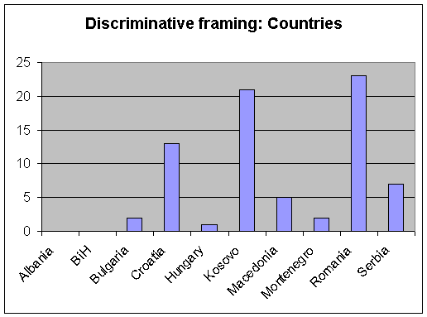

COUNTRY | Items | %
Albania | 0 | 0
BiH | 0 | 0
Bulgaria | 2 | 2.7
Croatia | 13 | 17.57
Hungary | 1 | 1.35
Kosovo | 21 | 28.38
Macedonia | 5 | 6.76
Montenegro | 2 | 2.7
Romania | 23 | 31.08
Serbia | 7 | 9.46
Total | 74 | 100

A NOTE: An item is an article and its accompanying headlines, photographs and graphics, making up a distinct body of material, (regardless of its journalistic genre or place in the newspaper).

back
42. DISCRIMINATORY FRAMING: ACTORS

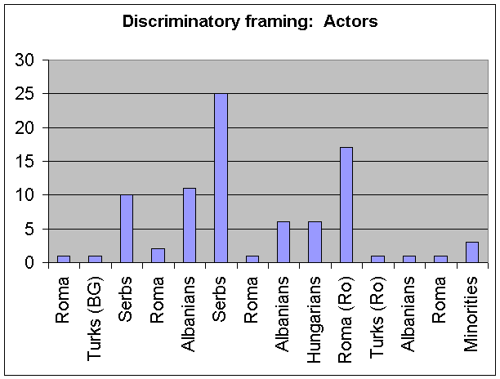

ACTORS | Items | %
Roma (BG) | 1 | 1.16
Turks (BG) | 1 | 1.16
Serbs (Cro) | 10 | 11.63
Roma (Cro) | 2 | 2.32
Albanians (Kos) | 11 | 12.79
Serbs (Kos) | 25 | 29.07
Roma (Mac) | 1 | 1.16
Albanians (Mac) | 6 | 6.98
Hungarians (Ro) | 6 | 6.98
Roma (Ro) | 17 | 19.78
Turks (Ro) | 1 | 1.16
Albanians (Ser) | 1 | 1.16
Roma (Ser) | 1 | 1.16
Minorities in general | 3 | 3.49
Total | 86 | 100

A NOTE: An item is an article and its accompanying headlines, photographs and graphics, making up a distinct body of material, (regardless of its journalistic genre or place in the newspaper).

back

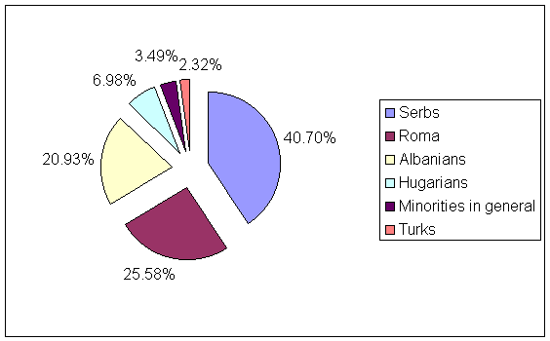

ACTORS | Items | %
Serbs | 35 | 40.7
Roma | 22 | 25.58
Albanians | 18 | 20.93
Hungarians | 6 | 6.98
Minorities in general | 3 | 3.49
Turks | 2 | 2.32
Total | 86 | 100

A NOTE: An item is an article and its accompanying headlines, photographs and graphics, making up a distinct body of material, (regardless of its journalistic genre or place in the newspaper).

back
43. DISCRIMINATORY FRAMING: HEADLINES

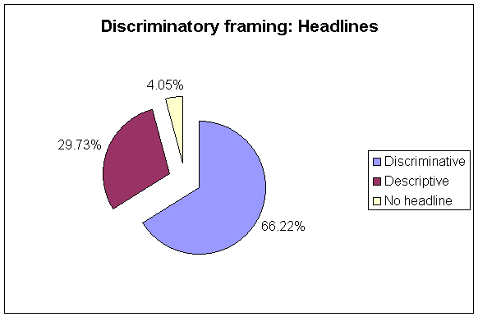

HEADLINES | Items | %
Discriminatory | 49 | 66.22
Descriptive | 22 | 29.73
No headline | 3 | 4.05
Total | 74 | 100

A NOTE: An item is an article and its accompanying headlines, photographs and graphics, making up a distinct body of material, (regardless of its journalistic genre or place in the newspaper).

back
44. DISCRIMINATORY FRAMING: SALIENCE

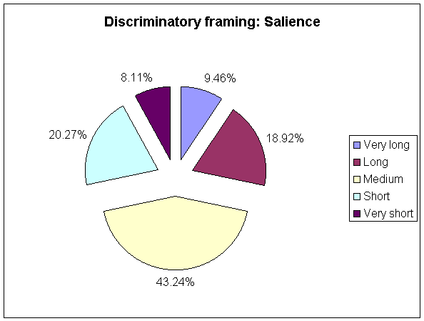

SALIENCE | Items | %
Very long | 7 | 9.46
Long | 14 | 18.92
Medium | 32 | 43.24
Short | 15 | 20.27
Very short | 6 | 8.11
Total | 74 | 100

A NOTE: An item is an article and its accompanying headlines, photographs and graphics, making up a distinct body of material, (regardless of its journalistic genre or place in the newspaper).

back
45. DISCRIMINATORY FRAMING: SECTION

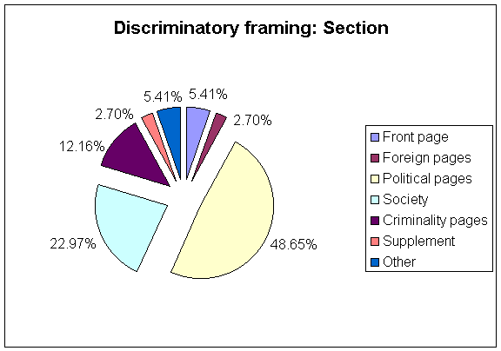

SECTION | Items | %
Front page | 4 | 5.41
Foreign pages | 2 | 2.7
Political pages | 36 | 48.65
Society | 17 | 22.97
Crime pages | 9 | 12.16
Supplement | 2 | 2.7
Other | 4 | 5.41
Total | 74 | 100

A NOTE: An item is an article and its accompanying headlines, photographs and graphics, making up a distinct body of material, (regardless of its journalistic genre or place in the newspaper).

back
46. DISCRIMINATORY FRAMING: TOPICS

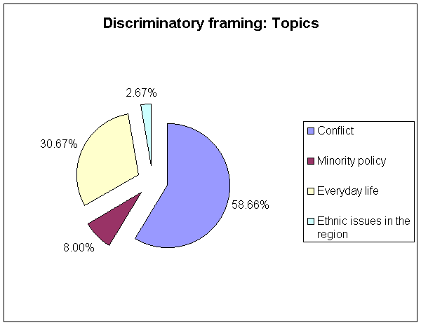

TOPICS | Items | %
Conflict | 44 | 58.66
Minority policy | 6 | 8
Everyday life | 23 | 30.67
Ethnic issues in the region | 2 | 2.67
Total | 75 | 100

A NOTE: An item is an article and its accompanying headlines, photographs and graphics, making up a distinct body of material, (regardless of its journalistic genre or place in the newspaper).

back

ALBANIA

1. ETHNIC MINORITIES AS ACTORS

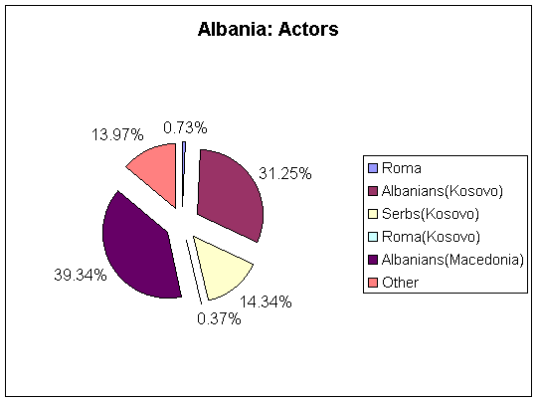

Albania: Actors
Actor | Items | %
Roma | 2 | 0.73
Albanians(Kosovo) | 85 | 31.25
Serbs(Kosovo) | 39 | 14.34
Roma(Kosovo) | 1 | 0.37
Albanians(Macedonia) | 107 | 39.34
Other | 38 | 13.97
Total | 272 | 100

Other actors
Actor | Items
Albanians abroad | 11
Kosovo minorities | 27
Total | 38

A NOTE: An item is an article and its accompanying headlines, photographs and graphics, making up a distinct body of material, (regardless of its journalistic genre or place in the newspaper).

back

ALBANIA

2. MAJOR ETHNIC ACTORS

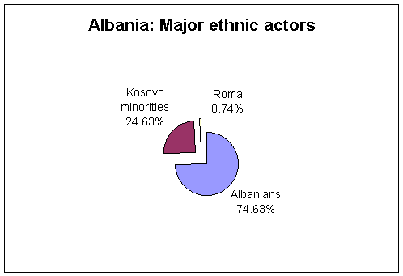

Actor | Items | %
Albanians | 203 | 74.63
Kosovo minorities | 67 | 24.63
Roma | 2 | 0.74
Total | 272 | 100

A NOTE: An item is an article and its accompanying headlines, photographs and graphics, making up a distinct body of material, (regardless of its journalistic genre or place in the newspaper).

back

ALBANIA

3. TOPICS OF THE ITEMS

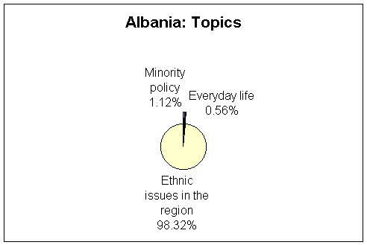

Topic | Items sum | %
Minority policy | 2 | 1.12
Everyday life | 1 | 0.56
Ethnic issues in the region | 176 | 98.32
Total | 179 | 100

A NOTE: An item is an article and its accompanying headlines, photographs and graphics, making up a distinct body of material, (regardless of its journalistic genre or place in the newspaper).

back

ALBANIA

4. TOPICS: ETHNIC ISSUES IN THE REGION

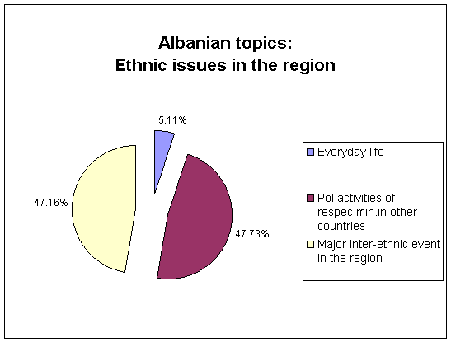

Topic | Items sum | %
Everyday life | 9 | 5.11
Pol.activities of respec.min.in other countries | 84 | 47.73
Major inter-ethnic event in the region | 83 | 47.16
Total | 176 | 100

A NOTE: An item is an article and its accompanying headlines, photographs and graphics, making up a distinct body of material, (regardless of its journalistic genre or place in the newspaper).

back

BOSNIA AND HERZEGOVINA

1. ETHNIC MINORITIES AS ACTORS

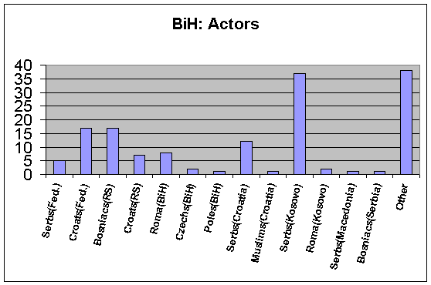

BiH actors | Items | %
Serbs(Fed.) | 5 | 3.36
Croats(Fed.) | 17 | 11.41
Bosniacs(RS) | 17 | 11.41
Croats(RS) | 7 | 4.71
Roma(BiH) | 8 | 5.37
Czechs(BiH) | 2 | 1.34
Poles(BiH) | 1 | 0.67
Serbs(Croatia) | 12 | 8.05
Muslims(Croatia) | 1 | 0.67
Serbs(Kosovo) | 37 | 24.83
Roma(Kosovo) | 2 | 1.34
Serbs(Macedonia) | 1 | 0.67
Bosniacs(Serbia) | 1 | 0.67
Other | 38 | 25.5
Total | 149 | 100
Other actors | Items
BiH minorities | 9
Croats in BiH | 6
Serbs in BiH | 1
Moslems in BiH | 2
Kosovo minorities | 9
Bosniacs in Kosovo | 2
FRY minorities | 1
RS minorities | 6
Minorities in general | 2
Total | 38
A NOTE: An item is an article and its accompanying headlines, photographs and graphics, making up a distinct body of material, (regardless of its journalistic genre or place in the newspaper).

back

BOSNIA AND HERZEGOVINA

2. MAJOR ETHNIC ACTORS

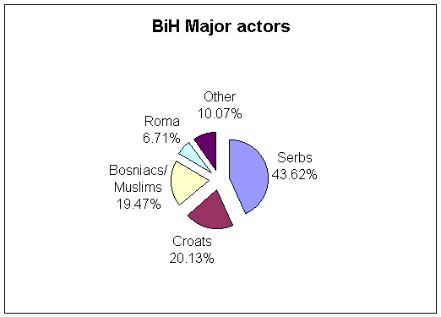

Actor | Items | %
Serbs | 65 | 43.62
Croats | 30 | 20.13
Bosniacs/Muslims | 29 | 19.47
Roma | 10 | 6.71
Other | 15 | 10.07
Total | 149 | 100

A NOTE: An item is an article and its accompanying headlines, photographs and graphics, making up a distinct body of material, (regardless of its journalistic genre or place in the newspaper).

back
BOSNIA AND HERZEGOVINA

3. TOPICS OF THE ITEMS

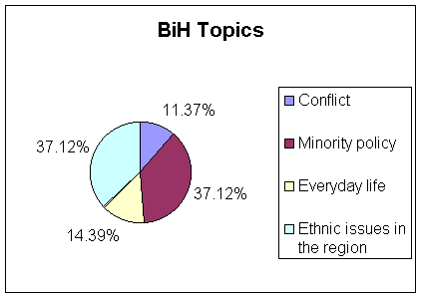

Topics | Items sum | %
Conflict | 15 | 11.37
Minority policy | 49 | 37.12
Everyday life | 19 | 14.39
Ethnic issues in the region | 49 | 37.12
Total | 132 | 100

A NOTE: An item is an article and its accompanying headlines, photographs and graphics, making up a distinct body of material, (regardless of its journalistic genre or place in the newspaper).

back

BOSNIA AND HERZEGOVINA

4. ETHNIC ISSUES IN THE REGION

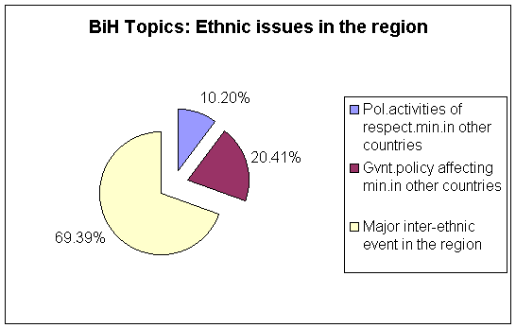

Topic | Items sum | %
Pol.activities of respect.min.in other countries | 5 | 10.2
Gvnt.policy affecting min.in other countries | 10 | 20.41
Major inter-ethnic event in the region | 34 | 69.39
Total | 49 | 100

A NOTE: An item is an article and its accompanying headlines, photographs and graphics, making up a distinct body of material, (regardless of its journalistic genre or place in the newspaper).

back

BOSNIA AND HERZEGOVINA

5. TOPIC: MINORITY POLICY

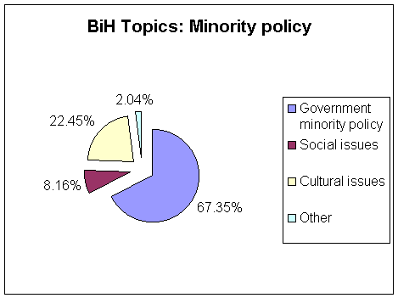

Topic | Items sum | %
Government minority policy | 33 | 67.35
Social issues | 4 | 8.16
Cultural issues | 11 | 22.45
Other | 1 | 2.04
Total | 49 | 100

A NOTE: An item is an article and its accompanying headlines, photographs and graphics, making up a distinct body of material, (regardless of its journalistic genre or place in the newspaper).

back

BULGARIA

1. ETHNIC MINORITIES AS ACTORS

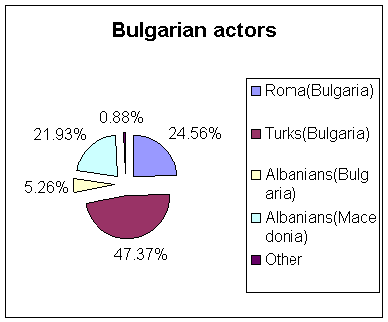

Bulgarian actors | Items | %
Roma(Bulgaria) | 28 | 24.56
Turks(Bulgaria) | 54 | 47.37
Albanians(Bulgaria) | 6 | 5.26
Albanians(Macedonia) | 25 | 21.93
Other | 1 | 0.88
Total | 114 | 100

Other actors | Items
Bulgarian minorities | 1

A NOTE: An item is an article and its accompanying headlines, photographs and graphics, making up a distinct body of material, (regardless of its journalistic genre or place in the newspaper).

back
BULGARIA

2. MAJOR ETHNIC ACTORS

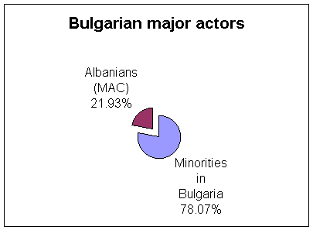

Actor | Items | %
Minorities in Bulg. | 89 | 78.07
Albanians (MAC) | 25 | 21.93
Total | 114 | 100

A NOTE: An item is an article and its accompanying headlines, photographs and graphics, making up a distinct body of material, (regardless of its journalistic genre or place in the newspaper).

back

BULGARIA

3. TOPICS OF THE ITEMS

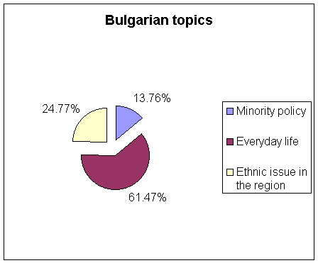

Topic | Item sum | %
Minority policy | 15 | 13.76
Everyday life | 67 | 61.47
Ethnic issue in the region | 27 | 24.77
Total | 109 | 100

A NOTE: An item is an article and its accompanying headlines, photographs and graphics, making up a distinct body of material, (regardless of its journalistic genre or place in the newspaper).

back

BULGARIA

4. EVERYDAY LIFE

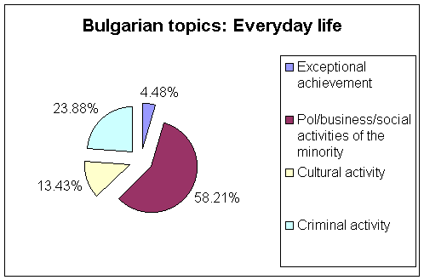

Topic | Item sum | %
Exceptional achievement | 3 | 4.48
Pol/business/social activities of the minority | 39 | 58.21
Cultural activity | 9 | 13.43
Criminal activity | 16 | 23.88
Total | 67 | 100

A NOTE: An item is an article and its accompanying headlines, photographs and graphics, making up a distinct body of material, (regardless of its journalistic genre or place in the newspaper).

back

CROATIA

1. ETHNIC MINORITIES AS ACTORS

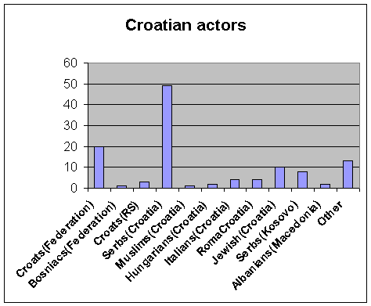

Actor | Items | %
  A NOTE: An item is an article and its accompanying headlines, photographs and graphics, making up a distinct body of material, (regardless of its journalistic genre or place in the newspaper).
Croats(Federation) | 20 | 17.09
Bosniacs(Federation) | 1 | 0.85
Croats(RS) | 3 | 2.56
Serbs(Croatia) | 49 | 41.88
Muslims(Croatia) | 1 | 0.85
Hungarians(Croatia) | 2 | 1.71
Italians(Croatia) | 4 | 3.42
RomaCroatia) | 4 | 3.42
Jewish(Croatia) | 10 | 8.55
Serbs(Kosovo) | 8 | 6.85
Albanians(Macedonia) | 2 | 1.71
Other | 13 | 11.11
Total | 117 | 100

Other actors | Items
Czechs | 1
Russians | 1
Serbs in BiH | 3
Croats abroad(It,Aus,BiH,Kos) | 5
Croatian minorities | 1
Minorities in general | 2
Total | 13

back

CROATIA

2. MAJOR ETHNIC ACTORS

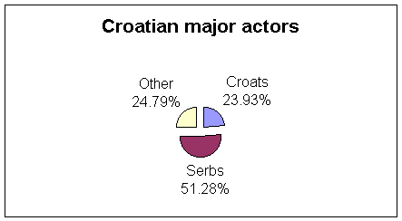

Actor | Items | %
Croats | 28 | 23.93
Serbs | 60 | 51.28
Other | 29 | 24.79
Total | 117 | 100

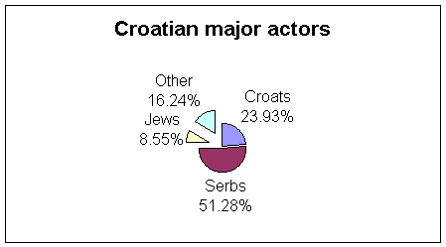

Actor | Items | %
  A NOTE: An item is an article and its accompanying headlines, photographs and graphics, making up a distinct body of material, (regardless of its journalistic genre or place in the newspaper).
Croats | 28 | 23.93
Serbs | 60 | 51.28
Jews | 10 | 8.55
Other | 19 | 16.24
Total | 117 | 100

back

CROATIA

3. TOPICS OF THE ITEMS

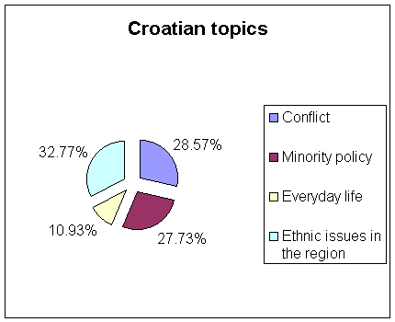

Topic | Item sum | %
Conflict | 34 | 28.57
Minority policy | 33 | 27.73
Everyday life | 13 | 10.93
Ethnic issues in the region | 39 | 32.77
Total | 119 | 100

A NOTE: An item is an article and its accompanying headlines, photographs and graphics, making up a distinct body of material, (regardless of its journalistic genre or place in the newspaper).

back

CROATIA

4. TOPIC: ETHNIC ISSUES IN THE REGION

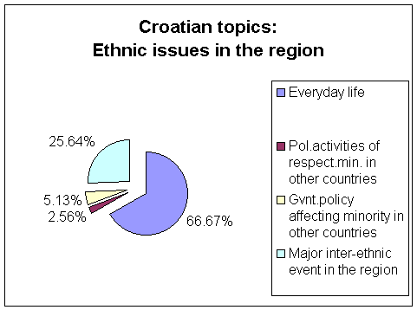

Topic | Item sum | %
Everyday life | 26 | 66.67
Pol.activities of respect.min. in other countries | 1 | 2.56
Gvnt.policy affecting minority in other countries | 2 | 5.13
Major inter-ethnic event in the region | 10 | 25.64
Total | 39 | 100

A NOTE: An item is an article and its accompanying headlines, photographs and graphics, making up a distinct body of material, (regardless of its journalistic genre or place in the newspaper).

back

CROATIA

5. TOPIC: MINORITY POLICY

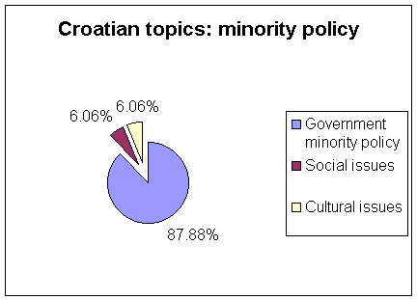

Topic | Item sum | %
Government minority policy | 29 | 87.88
Social issues | 2 | 6.06
Cultural issues | 2 | 6.06
Total | 33 | 100

A NOTE: An item is an article and its accompanying headlines, photographs and graphics, making up a distinct body of material, (regardless of its journalistic genre or place in the newspaper).

back

HUNGARY

1. ETHNIC MINORITIES AS ACTORS

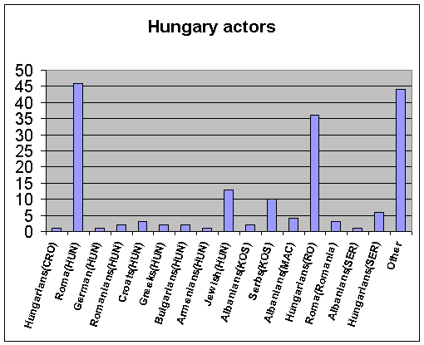

Actor | Items | %
  A NOTE: An item is an article and its accompanying headlines, photographs and graphics, making up a distinct body of material, (regardless of its journalistic genre or place in the newspaper).
Hungarians(CRO) | 1 | 0.56
Roma(HUN) | 46 | 25.99
German(HUN) | 1 | 0.56
Romanians(HUN) | 2 | 1.13
Croats(HUN) | 3 | 1.7
Greeks(HUN) | 2 | 1.13
Bulgarians(HUN) | 2 | 1.13
Armenians(HUN) | 1 | 0.56
Jewish(HUN) | 13 | 7.34
Albanians(KOS) | 2 | 1.13
Serbs(KOS) | 10 | 5.65
Albanians(MAC) | 4 | 2.26
Hungarians(RO) | 36 | 20.35
Roma(Romania) | 3 | 1.7
Albanians(SER) | 1 | 0.56
Hungarians(SER) | 6 | 3.39
Other | 44 | 24.86
Total | 177 | 100

Other actors | Items
Hungarians | 29
Kosovo minorities | 2
Minorities in general | 13
Total | 44
back

HUNGARY

2. MAJOR ETHNIC ACTORS

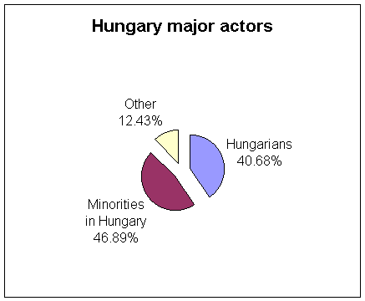

Actor | Items | %
Hungarians | 72 | 40.68
Minorities in Hungary | 83 | 46.89
Other | 22 | 12.43
Total | 177 | 100

A NOTE: An item is an article and its accompanying headlines, photographs and graphics, making up a distinct body of material, (regardless of its journalistic genre or place in the newspaper).

back

HUNGARY

3. TOPICS OF THE ITEMS

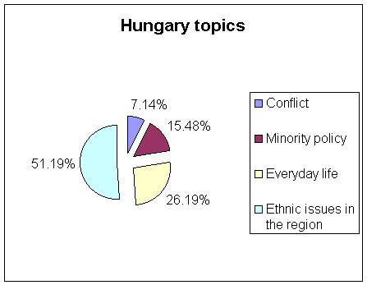

Topic | Item sum | %
Conflict | 12 | 7.14
Minority policy | 26 | 15.48
Everyday life | 44 | 26.19
Ethnic issues in the region | 86 | 51.19
Total | 168 | 100

A NOTE: An item is an article and its accompanying headlines, photographs and graphics, making up a distinct body of material, (regardless of its journalistic genre or place in the newspaper).

back

HUNGARY

4. TOPIC: ETHNIC ISSUES IN THE REGION

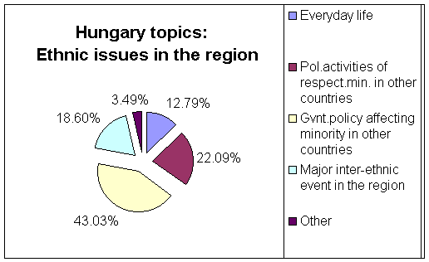

Topic | Item sum | %
Everyday life | 11 | 12.79
Pol.activities of respect.min. in other countries | 19 | 22.09
Gvnt.policy affecting minority in other countries | 37 | 43.03
Major inter-ethnic event in the region | 16 | 18.6
Other | 3 | 3.49
Total | 86

A NOTE: An item is an article and its accompanying headlines, photographs and graphics, making up a distinct body of material, (regardless of its journalistic genre or place in the newspaper).

back

HUNGARY

5. TOPIC: EVERYDAY LIFE

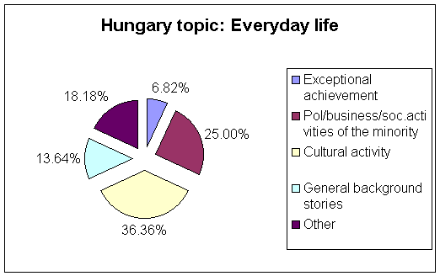

Topic | Items sum | %
Exceptional achievement | 3 | 6.82
Pol/business/soc.activities of the minority | 11 | 25
Cultural activity | 16 | 36.36
General background stories | 6 | 13.64
Other | 8 | 18.18
Total | 44 | 100

A NOTE: An item is an article and its accompanying headlines, photographs and graphics, making up a distinct body of material, (regardless of its journalistic genre or place in the newspaper).

back

KOSOVO

1. MAJOR ETHNIC ACTORS

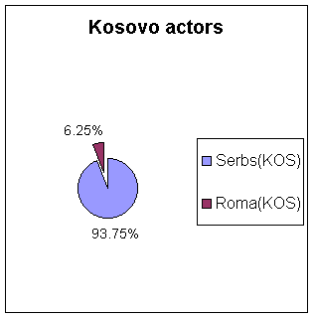

Actor | Items | %
Serbs(KOS) | 90 | 93.75
Roma(KOS) | 6 | 6.25
Total | 96 | 100

A NOTE: An item is an article and its accompanying headlines, photographs and graphics, making up a distinct body of material, (regardless of its journalistic genre or place in the newspaper).

back

KOSOVO

2. TOPICS OF THE ITEMS

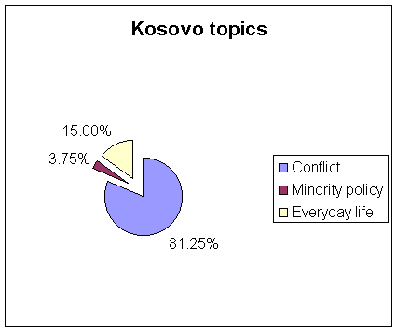

Topic | Items sum | %
Conflict | 65 | 81.25
Minority policy | 3 | 3.75
Everyday life | 12 | 15
Total | 80 | 100

A NOTE: An item is an article and its accompanying headlines, photographs and graphics, making up a distinct body of material, (regardless of its journalistic genre or place in the newspaper).

back

KOSOVO

3. TOPIC: CONFLICT

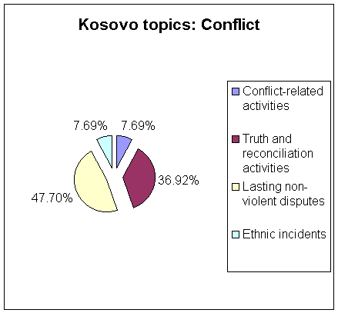

Topic | Item sum | %
Conflict-related activities | 5 | 7.69
Truth and reconciliation activities | 24 | 36.92
Lasting non-violent disputes | 31 | 47.7
Ethnic incidents | 5 | 7.69
Total | 65 | 100

A NOTE: An item is an article and its accompanying headlines, photographs and graphics, making up a distinct body of material, (regardless of its journalistic genre or place in the newspaper).

back

MACEDONIA

1. ETHNIC MINORITIES AS ACTORS

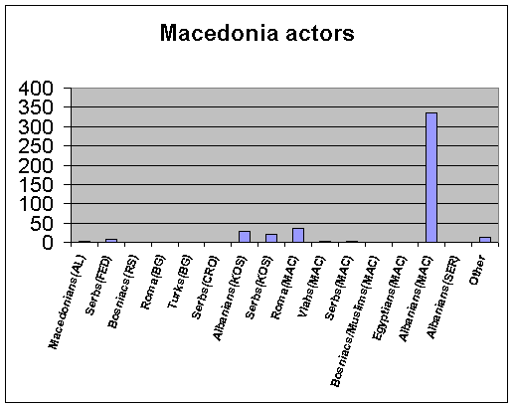

Actor | Items | %
  A NOTE: An item is an article and its accompanying headlines, photographs and graphics, making up a distinct body of material, (regardless of its journalistic genre or place in the newspaper).
Macedonians(AL) | 2 | 0.44
Serbs(FED) | 7 | 1.55
Bosniacs(RS) | 1 | 0.22
Roma(BG) | 1 | 0.22
Turks(BG) | 1 | 0.22
Serbs(CRO) | 1 | 0.22
Albanians(KOS) | 28 | 6.18
Serbs(KOS) | 21 | 4.64
Roma(MAC) | 36 | 7.95
Vlahs(MAC) | 3 | 0.66
Serbs(MAC) | 2 | 0.44
Bosniacs/Muslims(MAC) | 1 | 0.22
Egyptians(MAC) | 1 | 0.22
Albanians(MAC) | 335 | 73.95
Albanians(SER) | 1 | 0.22
Other | 12 | 2.65
Total | 453 | 100

Actor | Items
Muslims in MAC | 2
MAC minorities | 7
Kosovo minorities | 3
Total | 12
back

MACEDONIA

2. MAJOR ETHNIC ACTORS

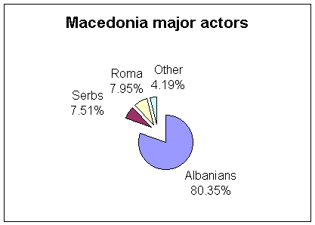

Actor | Items
  A NOTE: An item is an article and its accompanying headlines, photographs and graphics, making up a distinct body of material, (regardless of its journalistic genre or place in the newspaper).
Albanians | 364
Serbs | 34
Roma | 36
Other | 19
Total | 453

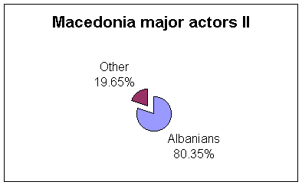

Actor | Items | %
Albanians | 364 | 80.35
Other | 89 | 19.65
Total | 453 | 100

back

MACEDONIA

3. TOPICS OF THE ITEMS

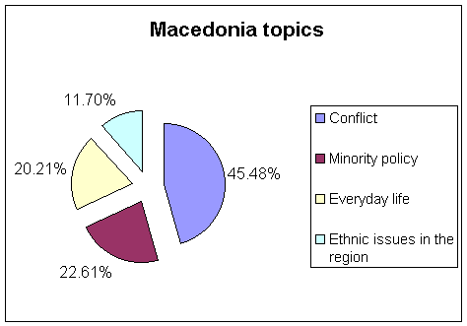

Topic | Item sum
Conflict | 171
Minority policy | 85
Everyday life | 76
Ethnic issues in the region | 44
Total | 376

A NOTE: An item is an article and its accompanying headlines, photographs and graphics, making up a distinct body of material, (regardless of its journalistic genre or place in the newspaper).

back

MACEDONIA

4. TOPIC: CONFLICT

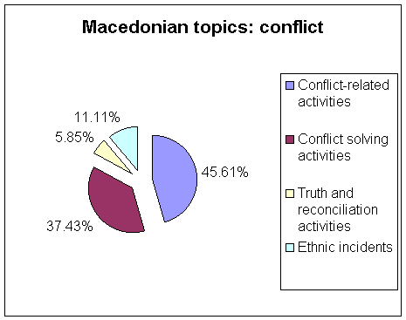

Topic | Item sum | %
Conflict-related activities | 78 | 45.61
Conflict solving activities | 64 | 37.43
Truth and reconciliation activities | 10 | 5.85
Ethnic incidents | 19 | 11.11
Total | 171 | 100

A NOTE: An item is an article and its accompanying headlines, photographs and graphics, making up a distinct body of material, (regardless of its journalistic genre or place in the newspaper).

back

MONTENEGRO

1. ETHNIC MINORITIES AS ACTORS

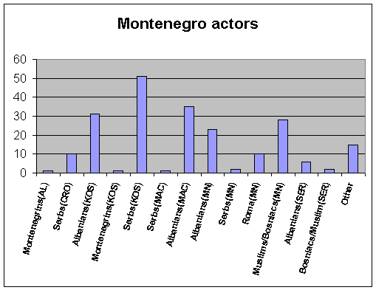

Actor | Items | %
  A NOTE: An item is an article and its accompanying headlines, photographs and graphics, making up a distinct body of material, (regardless of its journalistic genre or place in the newspaper).
Montenegrins(AL) | 1 | 0.46
Serbs(CRO) | 10 | 4.63
Albanians(KOS) | 31 | 14.35
Montenegrins(KOS) | 1 | 0.46
Serbs(KOS) | 51 | 23.61
Serbs(MAC) | 1 | 0.46
Albanians(MAC) | 35 | 16.2
Albanians(MN) | 23 | 10.65
Serbs(MN) | 2 | 0.93
Roma(MN) | 10 | 4.63
Muslims/Bosniacs(MN) | 28 | 12.96
Albanians(SER) | 6 | 2.78
Bosniacs/Muslim(SER) | 2 | 0.93
Other | 15 | 6.95
Total | 216 | 100

Actor | Items
Kosovo Bosniacs | 1
Muslims in BiH | 1
Serbs in BiH | 1
Minorities in CRO | 4
Minorities in SER | 4
Macedonians in SER | 1
Minorities in general | 3
Total | 15
back

MONTENEGRO

1a. ETHNIC MINORITIES AS ACTORS

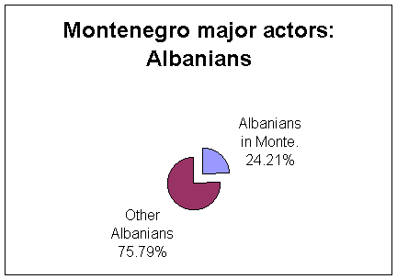
A NOTE: An item is an article and its accompanying headlines, photographs and graphics, making up a distinct body of material, (regardless of its journalistic genre or place in the newspaper).
.

Actor | Items | %
Albanians in Montenegro | 23 | 24.21
Other Albanians | 72 | 75.79
Total | 95 | 100

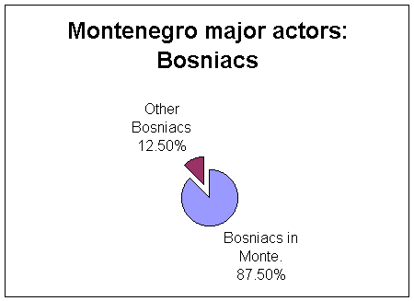

Actor | Items
Bosniacs in Montenegro | 28
Other Bosniacs | 4
Total | 32

back

MONTENEGRO

2. MAJOR ETHNIC ACTORS

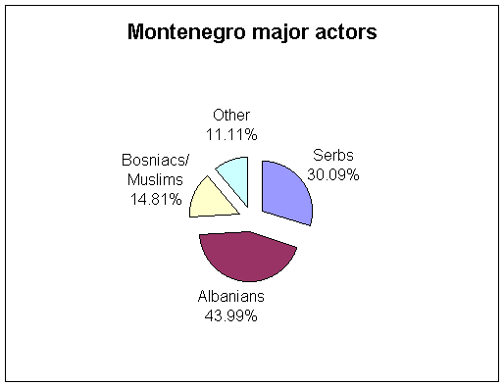

Actor | Items | %
Serbs | 65 | 30.09
Albanians | 95 | 43.99
Bosniacs/Muslims | 32 | 14.81
Other | 24 | 11.11
Total | 216 | 100

A NOTE: An item is an article and its accompanying headlines, photographs and graphics, making up a distinct body of material, (regardless of its journalistic genre or place in the newspaper).

back

MONTENEGRO

3. TOPICS OF THE ITEMS

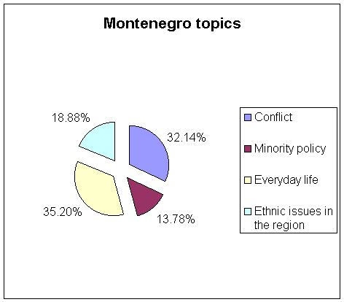

Topic | Item sum | %
Conflict | 63 | 32.14
Minority policy | 27 | 13.78
Everyday life | 69 | 35.2
Ethnic issues in the region | 37 | 18.88
Total | 196 | 100

A NOTE: An item is an article and its accompanying headlines, photographs and graphics, making up a distinct body of material, (regardless of its journalistic genre or place in the newspaper).

back

ROMANIA

1. ETHNIC MINORITIES AS ACTORS

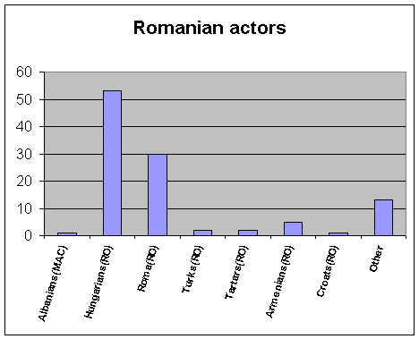

Actor | Items | %
Albanians(MAC) | 1 | 0.93
Hungarians(RO) | 53 | 49.53
Roma(RO) | 30 | 28.04
Turks(RO) | 2 | 1.87
Tartars(RO) | 2 | 1.87
Armenians(RO) | 5 | 4.68
Croats(RO) | 1 | 0.93
Other | 13 | 12.15
Total | 107 | 100

Actor | Items
Csango | 2
Hungarians | 6
Romanians | 1
RO minorities | 2
Minorities in general | 2
Total | 13

A NOTE: An item is an article and its accompanying headlines, photographs and graphics, making up a distinct body of material, (regardless of its journalistic genre or place in the newspaper).

back

ROMANIA

2. MAJOR ETHNIC ACTORS

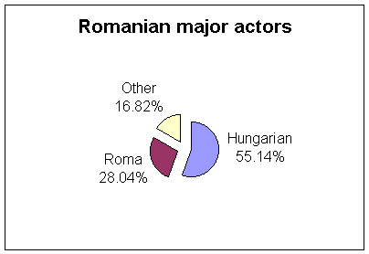

Actor | Items | %
Hungarians | 59 | 55.14
Roma | 30 | 28.04
Other | 18 | 16.82
Total | 107 | 100

A NOTE: An item is an article and its accompanying headlines, photographs and graphics, making up a distinct body of material, (regardless of its journalistic genre or place in the newspaper).

back

ROMANIA

3. TOPICS OF THE ITEMS

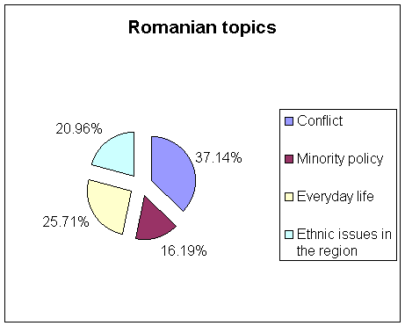

Topic | Item sum | %
Conflict | 39 | 37.14
Minority policy | 17 | 16.19
Everyday life | 27 | 25.71
Ethnic issues in the region | 22 | 20.96
Total | 105 | 100

A NOTE: An item is an article and its accompanying headlines, photographs and graphics, making up a distinct body of material, (regardless of its journalistic genre or place in the newspaper).

back

ROMANIA

4. TOPIC: CONFLICT

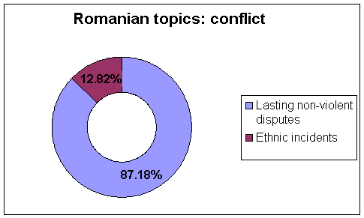

Topic | Item sum | %
Lasting non-violent disputes | 34 | 87.18
Ethnic incidents | 5 | 12.82
Total | 39 | 100

A NOTE: An item is an article and its accompanying headlines, photographs and graphics, making up a distinct body of material, (regardless of its journalistic genre or place in the newspaper).

back

ROMANIA

5. TOPIC: EVERYDAY LIFE

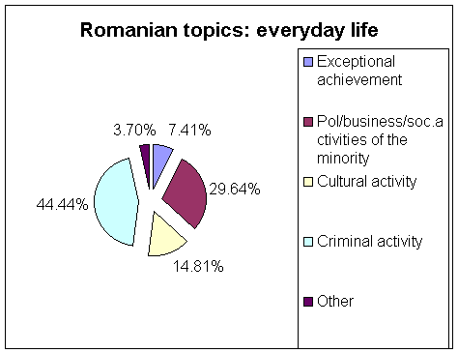

Topic | Item sum | %
Exceptional achievement | 2 | 7.41
Pol/business/soc.activities of the minority | 8 | 29.64
Cultural activity | 4 | 14.81
Criminal activity | 12 | 44.44
Other | 1 | 3.7
Total | 27

A NOTE: An item is an article and its accompanying headlines, photographs and graphics, making up a distinct body of material, (regardless of its journalistic genre or place in the newspaper).

back

SERBIA

1. ETHNIC MINORITIES AS ACTORS

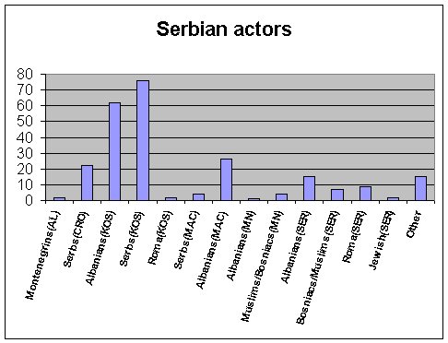
A NOTE: An item is an article and its accompanying headlines, photographs and graphics, making up a distinct body of material, (regardless of its journalistic genre or place in the newspaper).

Actor | Items | %
Montenegrins(AL) | 2 | 0.81
Serbs(CRO) | 22 | 8.91
Albanians(KOS) | 62 | 25.1
Serbs(KOS) | 76 | 30.78
Roma(KOS) | 2 | 0.81
Serbs(MAC) | 4 | 1.62
Albanians(MAC) | 26 | 10.53
Albanians(MN) | 1 | 0.4
Muslims/Bosniacs(MN) | 4 | 1.62
Albanians(SER) | 15 | 6.07
Bosniacs/Muslims(SER) | 7 | 2.83
Roma(SER) | 9 | 3.64
Jewish(SER) | 2 | 0.81
Other | 15 | 6.07
Total | 247 | 100

Other actors | Items
Croats in BiH | 2
Gora from Kosovo | 1
Kosovo nonalbanians | 1
SER minorities | 2
FRY minorities | 7
Balkan minorities | 1
Minorities in general | 1
Total | 15
back

SERBIA

2. MAJOR ETHNIC ACTORS

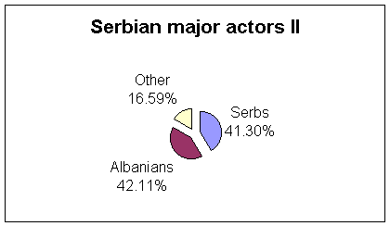

Actor | Items | %
Serbs | 102 | 41.3
Albanians | 104 | 42.11
Other | 41 | 16.59
Total | 247 | 100

A NOTE: An item is an article and its accompanying headlines, photographs and graphics, making up a distinct body of material, (regardless of its journalistic genre or place in the newspaper).

back

SERBIA

3. TOPICS OF THE ITEMS

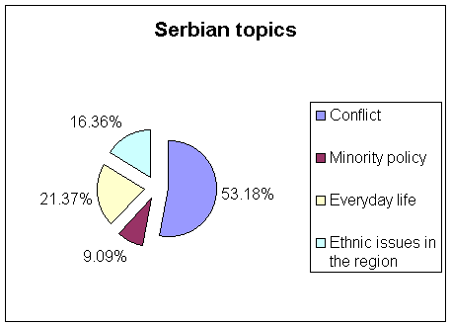

Topic | Item sum | %
Conflict | 117 | 53.18
Minority policy | 20 | 9.09
Everyday life | 47 | 21.37
Ethnic issues in the region | 36 | 16.36
Total | 220 | 36

A NOTE: An item is an article and its accompanying headlines, photographs and graphics, making up a distinct body of material, (regardless of its journalistic genre or place in the newspaper).

back

SERBIA

4. TOPIC: CONFLICT

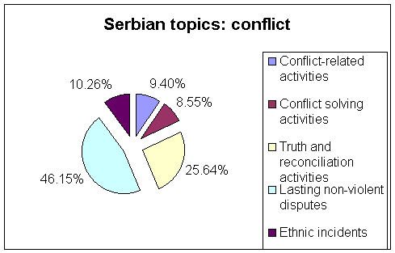

Topic | Item sum | %
Conflict-related activities | 11 | 9.4
Conflict solving activities | 10 | 8.55
Truth and reconciliation activities | 30 | 25.64
Lasting non-violent disputes | 54 | 46.15
Ethnic incidents | 12 | 10.26
Total | 117 | 100

A NOTE: An item is an article and its accompanying headlines, photographs and graphics, making up a distinct body of material, (regardless of its journalistic genre or place in the newspaper).

back

