Friday, 22 November, 2002, 15:24 GMT
Nigeria riots spread to capital
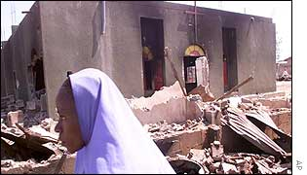
Several churches were destroyed in Kaduna
Hundreds of Muslim youths have gone on the rampage in Nigeria's capital, Abuja, following Friday prayers.
The BBC's Haruna Bahago in Abuja says people armed with sticks, daggers and knives set fire to vehicles and attacked anyone they suspected of being Christian.
The northern city of Kaduna is now quiet after two days of rioting in protest at the Miss World beauty contest, which left at least 100 people dead, according to Red Cross officials.
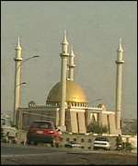
Miss World contestants are staying near Abuja's main mosque
The protests began after a newspaper suggested that the Prophet Mohammed would have probably chosen to marry one of the Miss World contestants if he had witnessed the beauty pageant - which Nigeria is currently hosting.
The contest's organisers said on Friday they intend to go ahead with the event despite the protests.
Surrounded
On Thursday, thousands of Muslim youths went through the suburbs of Kaduna, putting up barricades of burning tyres, setting fire to buildings, and attacking churches.
According to the Associated Press news agency, thousands of people have sought refuge in army bases and police stations.
Kaduna is one of Nigeria's most volatile cities; more than 2,000 people died there in clashes between Christians and Muslims two years ago.
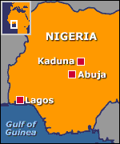
The Kaduna protesters demanded the cancellation of the Miss World contest. Muslim groups say it is immoral and degrading to women, and are also angry that preliminary events began during the holy month of Ramadan.
The final, to be held in Abuja, was postponed until 7 December - after the end of Ramadan.
Tight security
About 90 contestants are in Nigeria for the Miss World events, which are only taking place in southern areas which are largely Christian.
Our correspondent in Abuja says that many people suffered either knife wounds or beatings and the rioters were advancing on the city's central market.
He was himself surrounded by a group of angry Muslim radicals, who suspected he was Christian and had to shout "Allahu Akbar" (God is great) until they let him go.
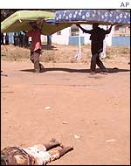
Kaduna's Christians fought back against Muslim radicals
The riots began at Abuja's central mosque, a short distance from the hotel where the Miss World contestants are staying amid tight security.
In Kaduna, mobs of minority Christian youths were reported to be retaliating against Muslims, and an overnight curfew was extended.
Red Cross spokesman George Bennett told the BBC that medical teams were working to give first aid to the injured, and that scores of bodies had been identified amid the debris.
Dogged by controversy
The Nigerian Government has appealed for calm and has assured Muslims that those responsible for the article, which appeared in ThisDay newspaper, would be brought to book, for exceeding "the bounds of responsible journalism."
ThisDay has retracted the offending article and has published apologies.
The chairman of the group that owns the Lagos-based paper suggested that a computer glitch could have been to blame for the fact that the story went to press in the first place.

Nigeria is hosting Miss World after Miss Nigeria won last year
The holding of the Miss World contest in Nigeria has also provoked international controversy.
It had been threatened by a boycott by beauty queens after a woman convicted of adultery, Amina Lawal, was sentenced to death by a Sharia court.
The Nigerian Government moved to calm fears by promising it would not allow any Nigerian to be stoned to death.

